

**KALLAM HARANADHAREDDY INSTITUTE OF TECHNOLOGY  
(AUTONOMOUS)**

Photographer Booking Platform on AWS: Effortless Event & Portrait

Scheduling

**By:**

**GONUGUNTA SRI SAI AMRUTHA**

[218x1a1253@khitguntur.ac.in](mailto:218x1a1253@khitguntur.ac.in)

**PASUPULATI BHAVANA**

[218x1a1226@khitguntur.ac.in](mailto:218x1a1226@khitguntur.ac.in)

**THANNIUR KANAKA PURNA CHANDRA RAO**

[218x1a1241@khitguntur.ac.in](mailto:218x1a1241@khitguntur.ac.in)

**DEVARAKONDA RAJASEKHAR**

[218x1a1208@khitguntur.ac.in](mailto:218x1a1208@khitguntur.ac.in)

Photographer Booking Platform on AWS: Effortless Event & Portrait Scheduling

## Project Description:

The "Photographer Booking Platform on AWS" is a cloud-based system designed to simplify the booking process for event and portrait photography. By leveraging AWS services like EC2 for hosting, RDS for managing booking data, and SNS for real-time notifications, the platform ensures a seamless experience for photographers and clients. The system provides flexible scheduling, secure data handling, and automatic notifications to keep both parties informed, all while maintaining high availability and scalability to support growing demand in the photography industry.

One of the platform’s key features is its use of AWS SNS (Simple Notification Service) to send instant notifications to photographers and clients. When a session is booked, the assigned photographer is immediately notified, and clients receive updates about their session status. The platform also allows for rescheduling and cancellations, with corresponding notifications sent in real time to ensure clear communication throughout the process.

## Scenario 1: Real-Time Notifications via AWS SNS

AWS SNS is integral to the platform’s smooth operation, sending instant notifications for every booking or update. When a client books a session, the photographer is immediately notified about the new job, ensuring they are always up to date with their schedule. Similarly, if a client reschedules or cancels, AWS SNS triggers notifications to both parties, keeping communication clear and efficient. This real-time notification system ensures that no appointments are missed and that both photographers and clients stay informed throughout the process.

## Scenario 2: Scalable Infrastructure for Managing High Booking Volumes

During peak seasons or popular event dates, the demand for photography services can spike, leading to increased platform traffic. The Photographer Booking Platform uses AWS EC2 to ensure it scales automatically, handling higher traffic without compromising performance. Whether it’s managing a surge of bookings during wedding season or processing multiple portrait sessions, AWS EC2 provides the flexibility and power needed to keep the platform running smoothly, adapting to the user load without downtime or delays.

## Scenario 3: Secure and Efficient Booking Data Management with AWS RDS

The platform stores all session details, client information, and photographer schedules securely using AWS RDS (MySQL). With automated backups, high availability, and robust security features, AWS RDS ensures that data is not only protected but also easily accessible when needed. This managed database solution allows the platform to handle large amounts of booking data efficiently, providing real-time insights and reports for photographers to manage their schedules and for clients to view their booking history securely.

**AWS Technical Architecture Diagram:**

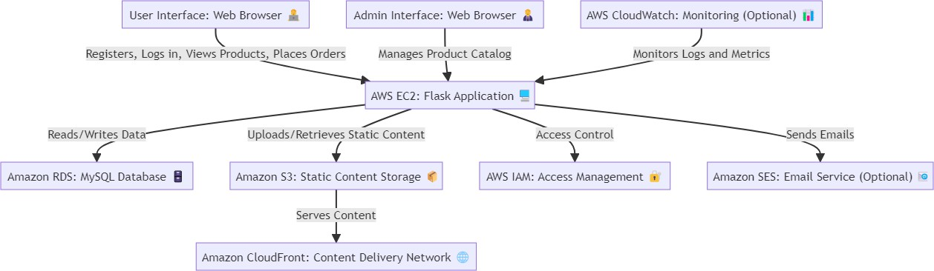

**ER-Diagram:**

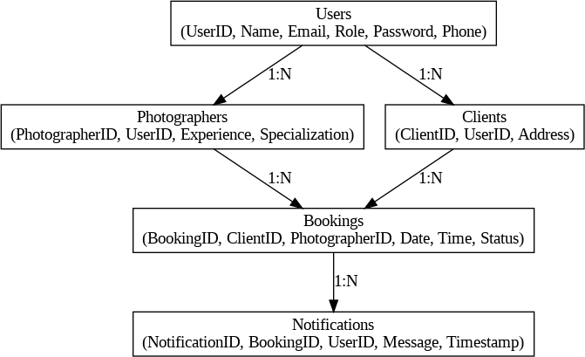

**Pre-requisites:**

1. AWS Account Setup: [https://youtu.be/CjKhQoYeR4Q?si=ui8Bvk_M4FfVM-D](https://youtu.be/CjKhQoYeR4Q?si=ui8Bvk_M4FfVM-Dh)h
2. Understanding of IAM: <https://youtu.be/gsgdAyGhV0o?si=3qg-bULgkD4LXNvR>
3. Knowledge of Amazon EC2 :<https://youtu.be/8TlukLu11Yo?si=MUj0nEAOESRhHUIz>
4. RDS : <https://www.youtube.com/live/MPau9c7PT74?si=A8OK-zFGbSKkAFWN>
5. MySQL WorkBench: <https://youtu.be/wALCw0F8e9M?si=ovMF9qMx5rLxaznB>
6. SNS : <https://youtu.be/yPbRwmZIG68?si=XzPLXwVSAca1twbG>

# Project WorkFlow:

## Project Initialization:

* + Define objectives, scope, and KPIs for deploying the Photographer Booking Platform on AWS: Effortless Event & Portrait Scheduling.
  + Set up the AWS environment, including EC2 instance configuration and RDS setup.
  + Outline the use of Flask for backend development and integration of AWS services.

## RDS Configuration:

* + Set up Amazon RDS for database management with MySQL.
  + Configure database instances, including security settings and access controls.

## SNS Topic Creation:

* + Create **AWS SNS topics** for project-related notifications.
  + Set up separate topics for faculty and students to receive notifications on project uploads and submissions.
  + Configure the system to trigger SNS notifications for various events such as new projects being uploaded or students submitting their work.

## Flask Application Deployment:

* + Develop and deploy the Photographer Booking Platform application using Flask.
  + Transfer application files to the EC2 instance and configure the environment.

## EC2 Instance Creation:

* + Launch an EC2 instance to host the Photographer Booking Platform application.
  + Select the appropriate instance type based on expected traffic and resource requirements.

## Testing and Optimization:

* + Test the application for functionality, performance, and security.
  + Optimize server settings, database configurations, and application performance.

# Milestone 1: AWS Account Setup and Login

## Activity 1.1: Create AWS Account

* + - Sign up for an AWS account and configure billing settings.

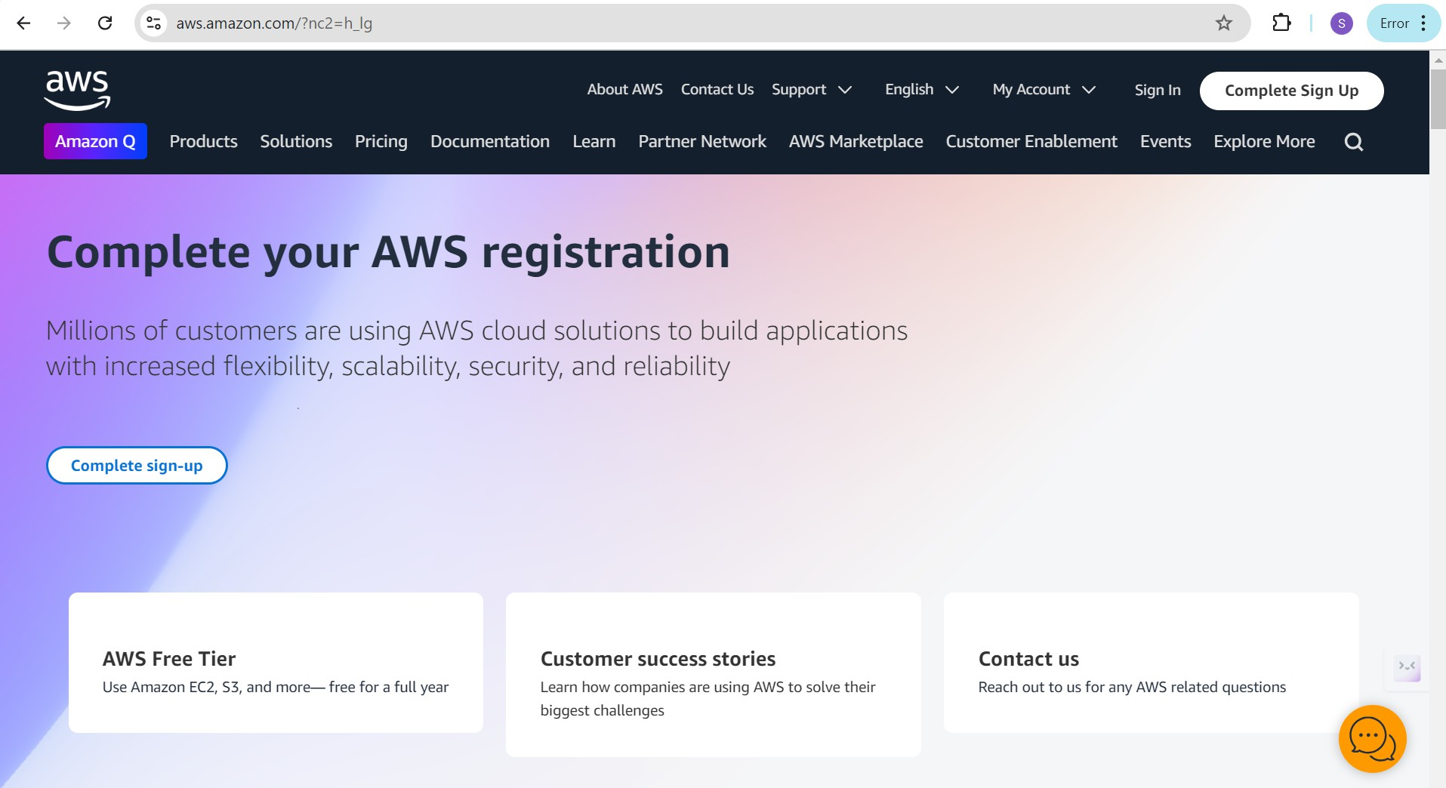

## Activity 1.2: Login to AWS Management Console

* + - Access the AWS Management Console using your login credentials.

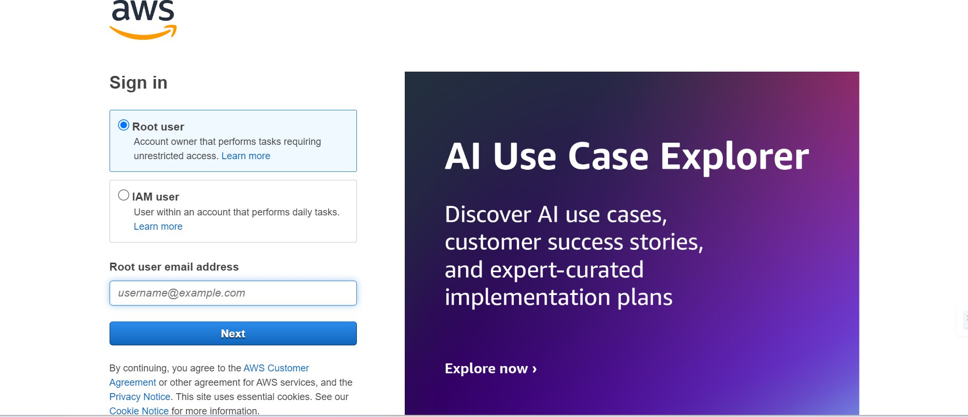

# Milestone 2: RDS Database Creation and Setup

## Activity 2.1: Create an RDS Instance

* + - Choose the RDS service from the AWS Management Console.

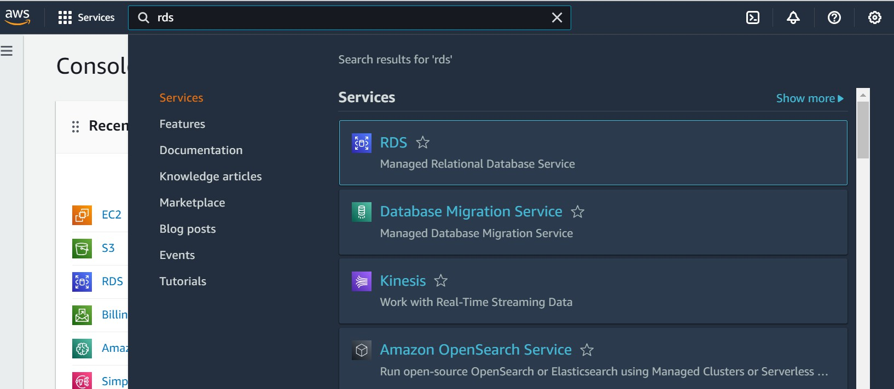

* + - Select MySQL as the database engine, configure the instance settings (e.g., storage, instance class), and launch the RDS instance.

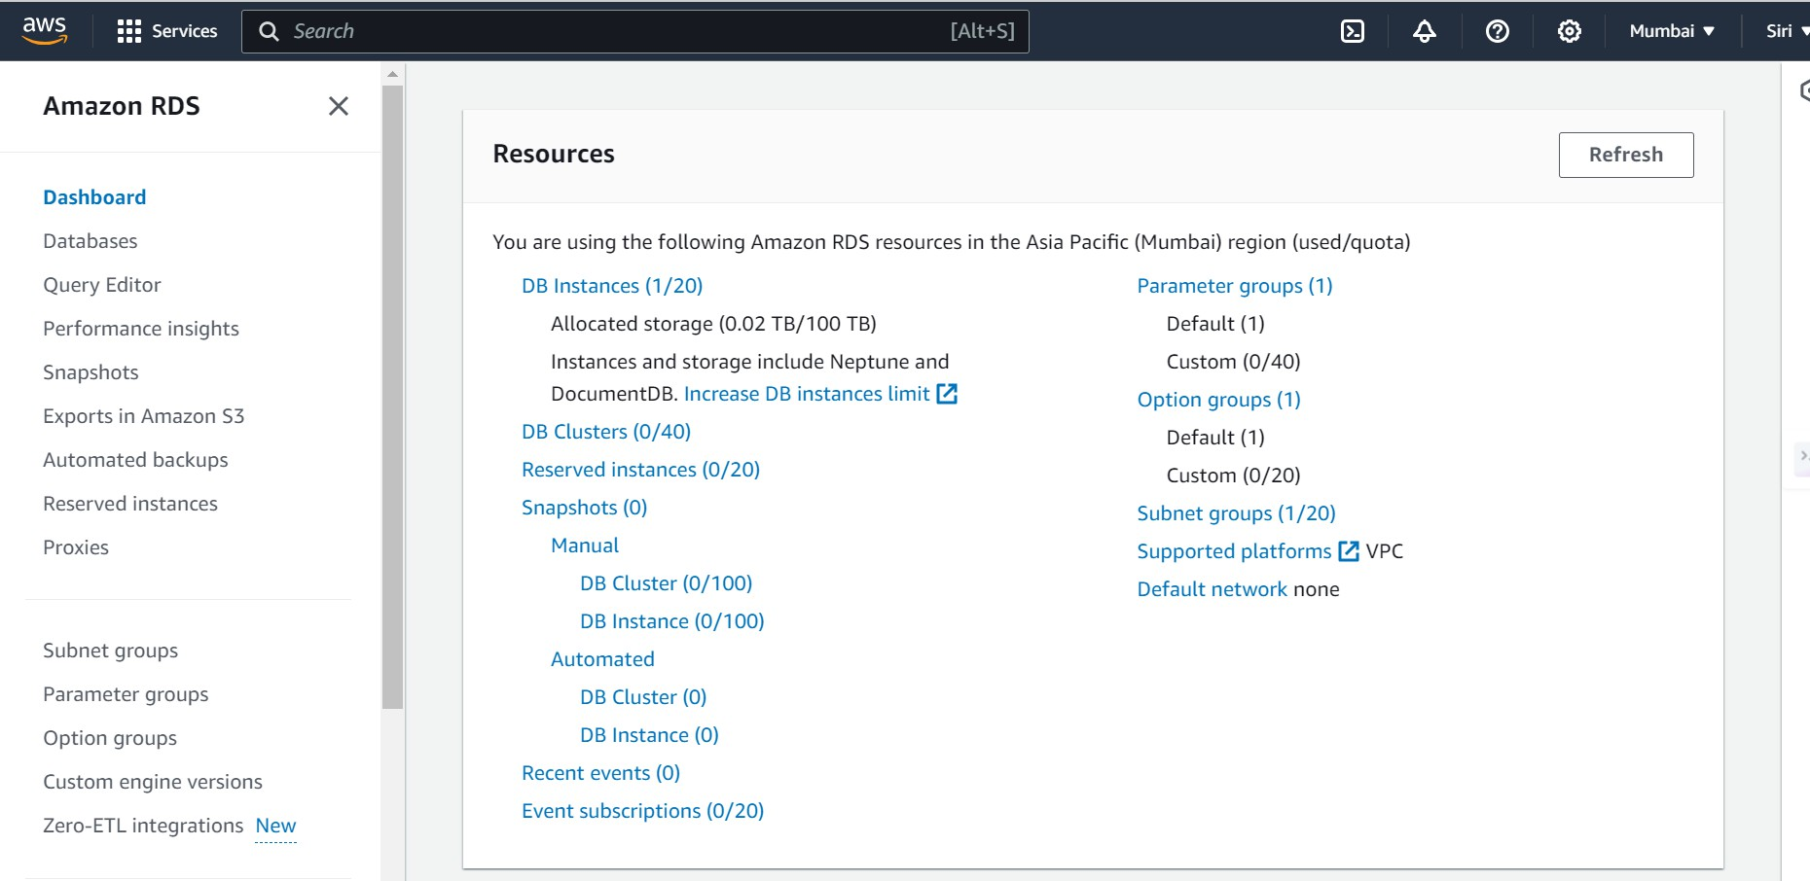

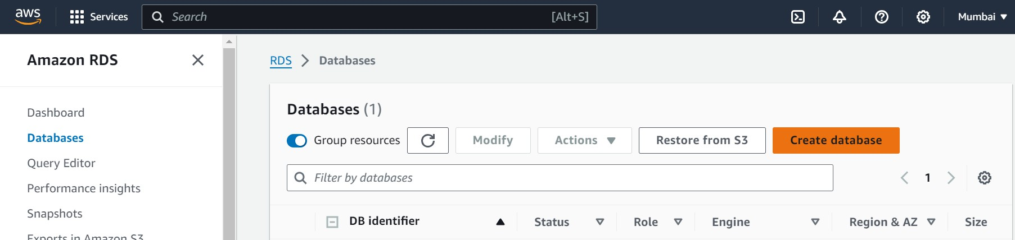

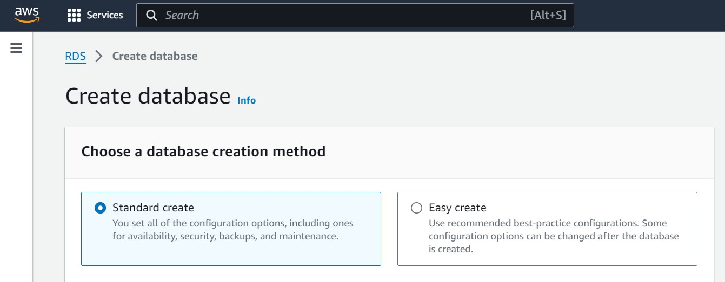

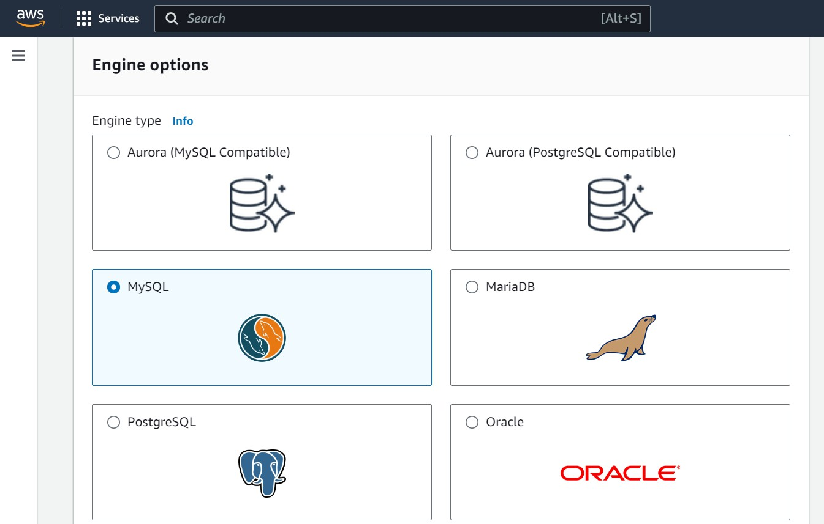

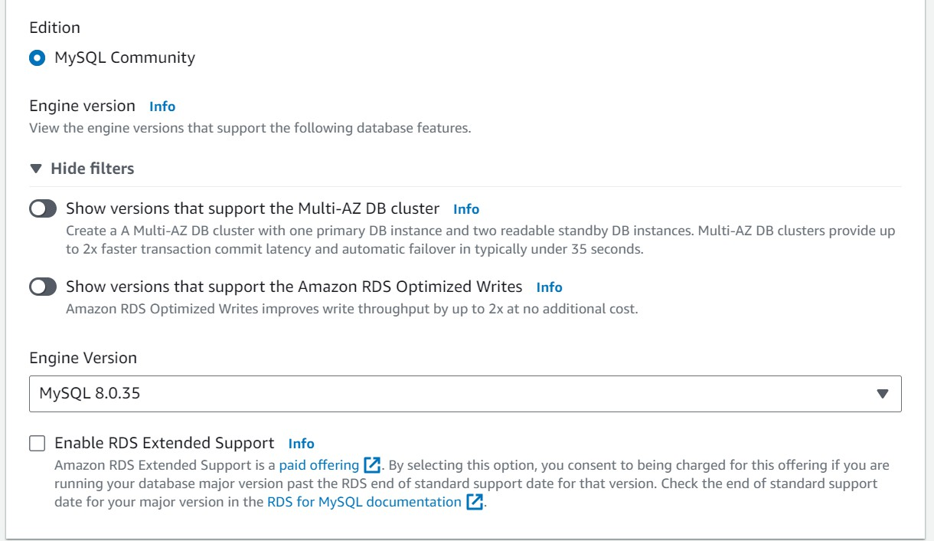

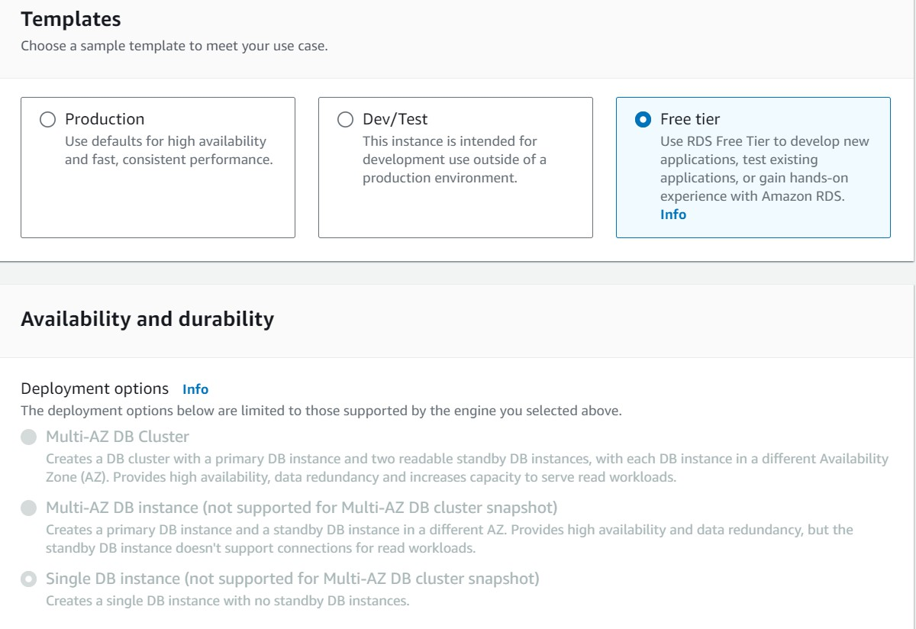

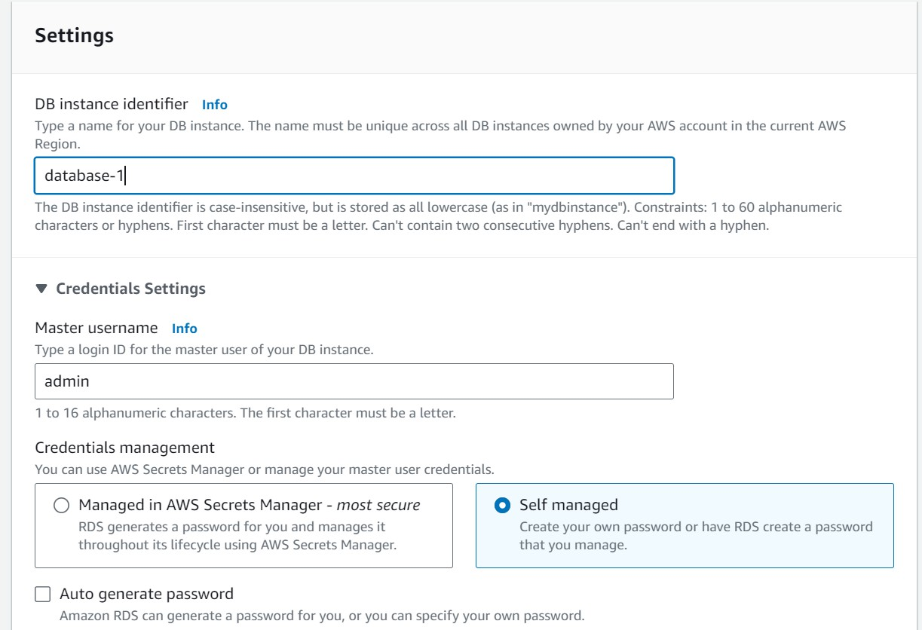

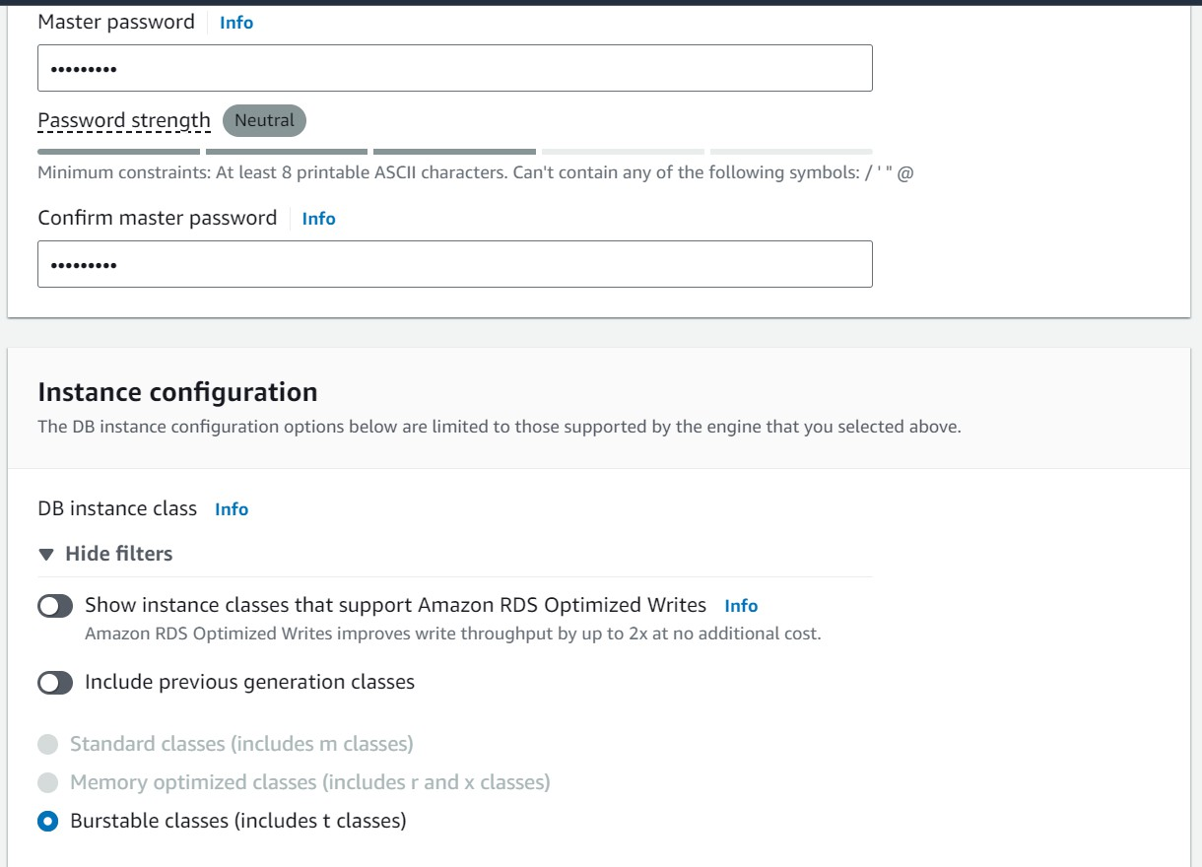

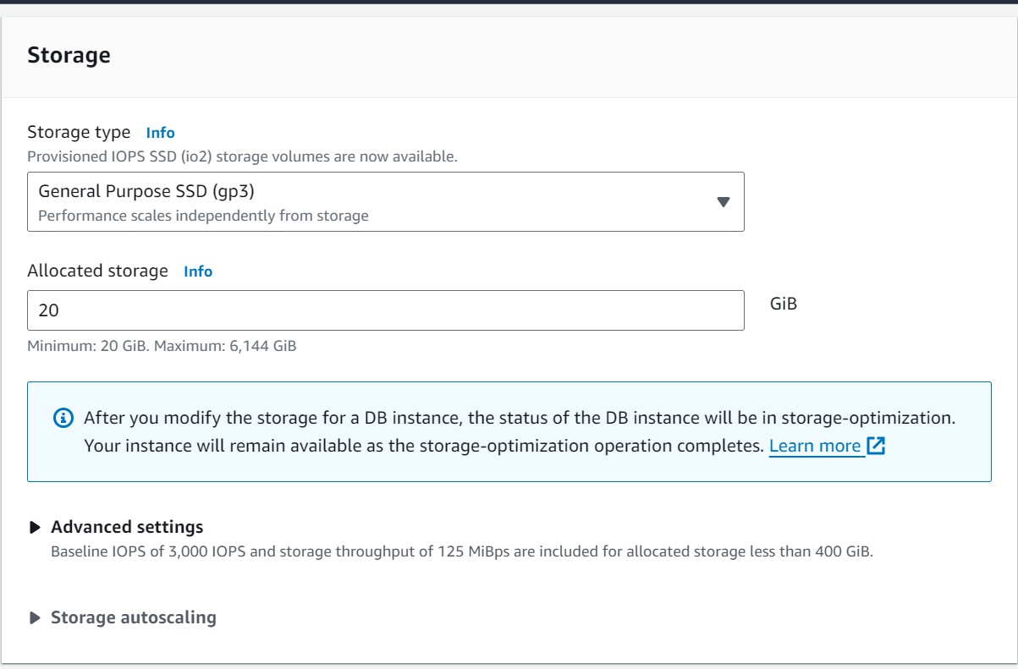

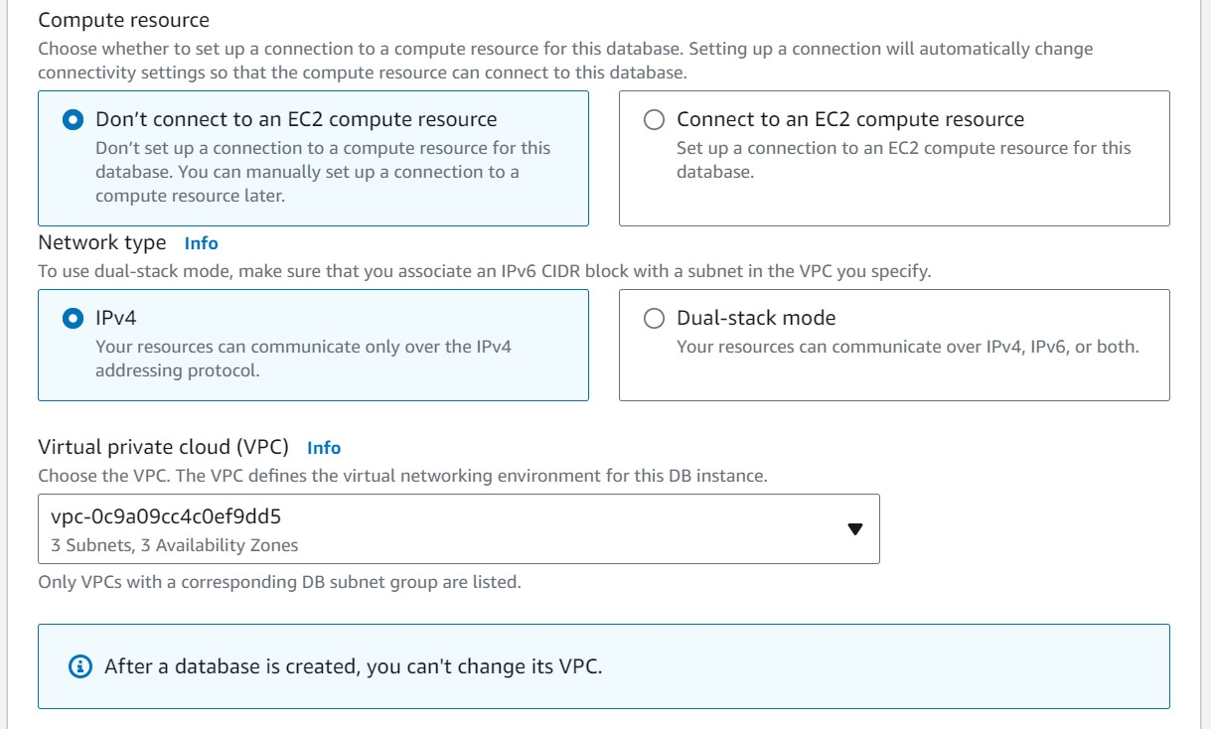

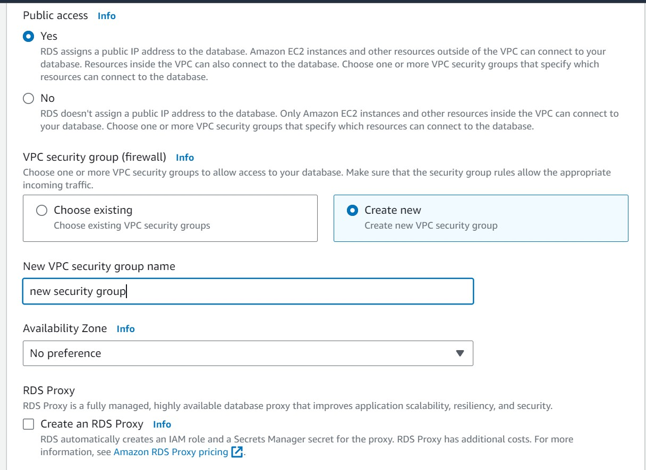

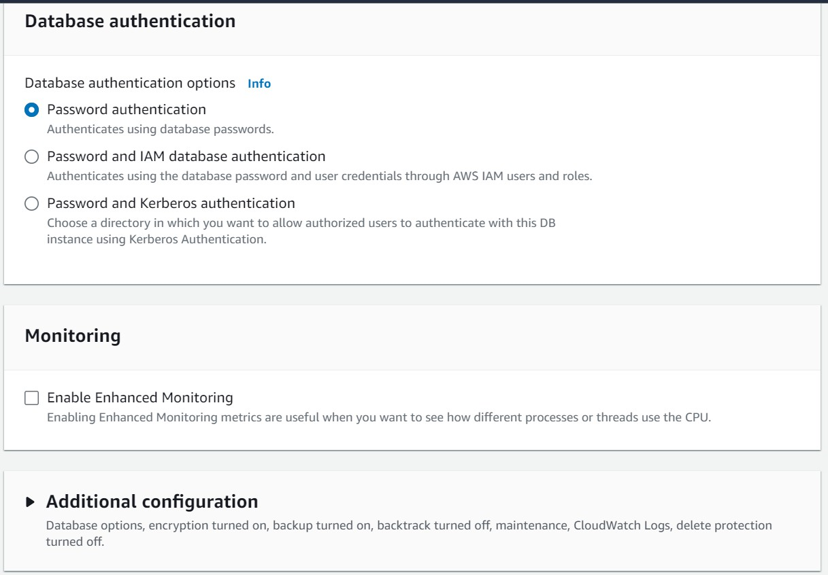

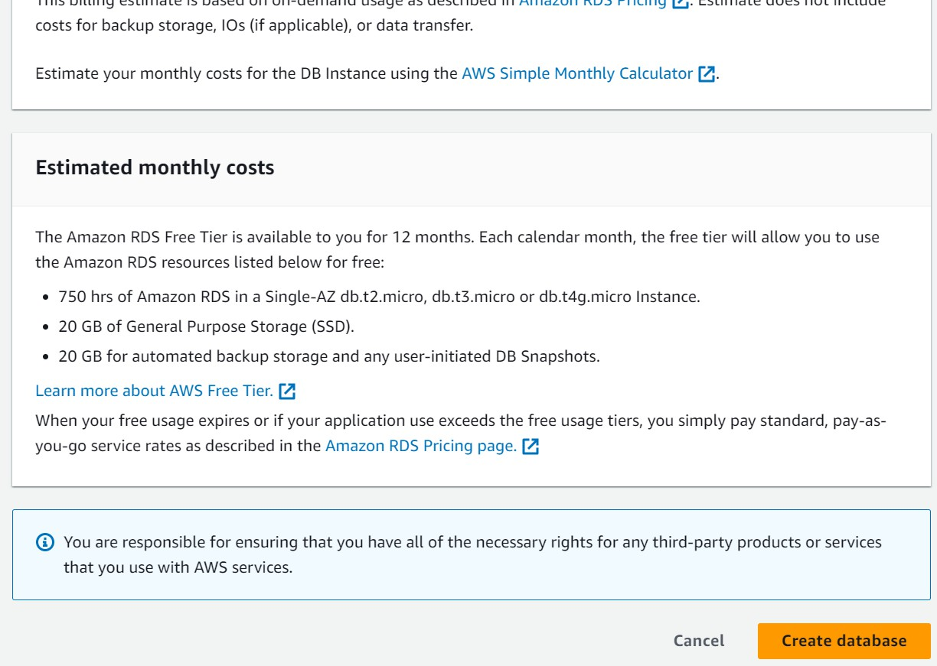

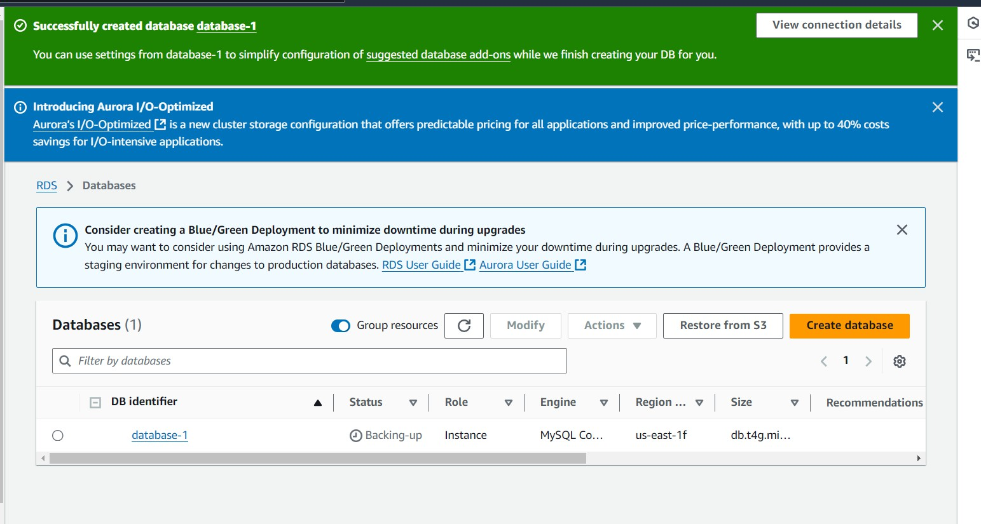

## Activity 2.2: Configure Database Access

* + Set up security groups, create database credentials, and configure access policies to ensure secure connectivity to the database.

## Activity 2.3: Install MySQL Workbench

* + Download and install MySQL Workbench on your local machine for database management.

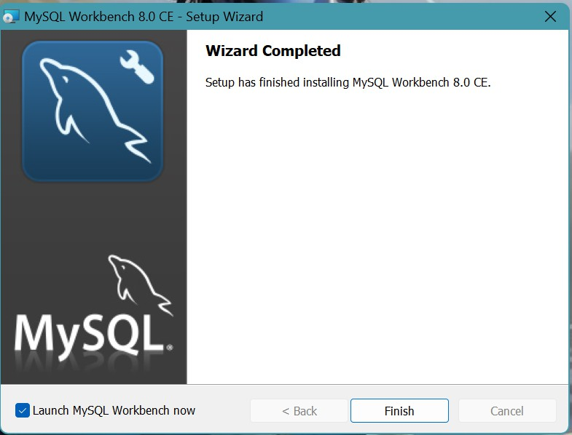

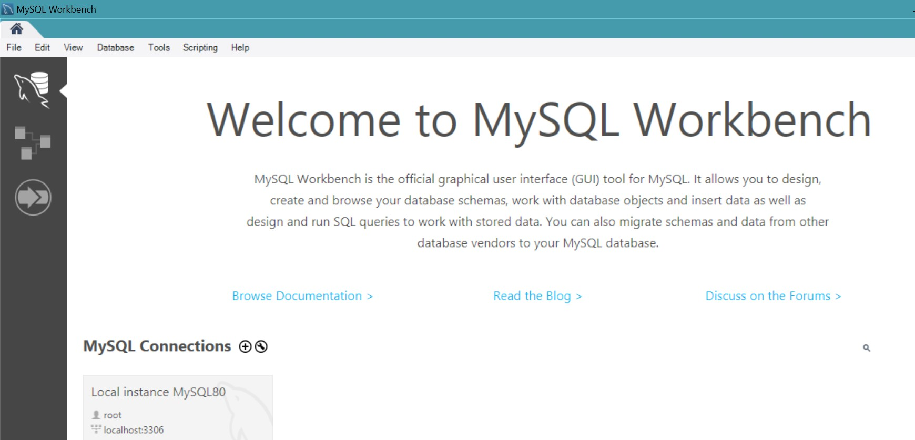

* + Connect to the RDS instance via MySQL Workbench using the endpoint and credentials from AW

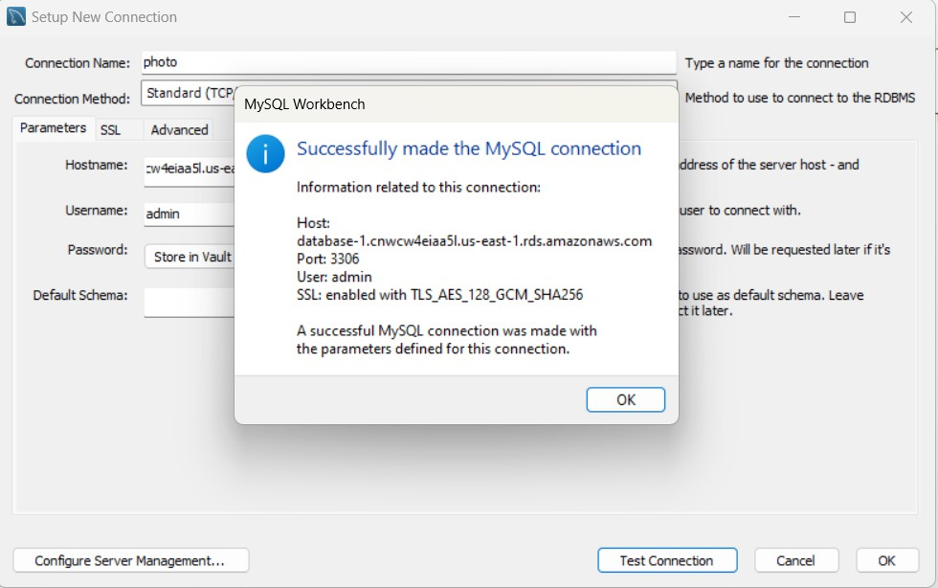

* Give a connection name.
* Copy the endpoint from the RDS database that is created in AWS and paste it in

### Hostname.

* Write the username and enter the password , then click on **Test Connection**.
* Once the connection is successful, you’ll be welcomed with this interface

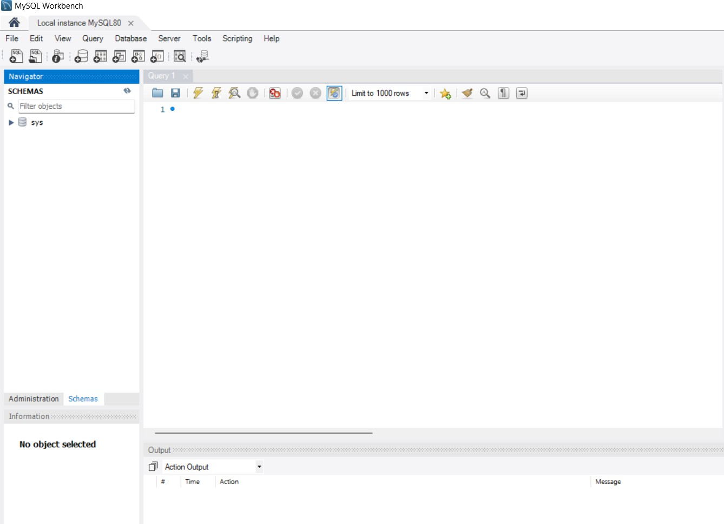

**Activity 2.4:** Create the Database and the tables which are required.

* **Create a basic database schema for an photographer Booking platform**

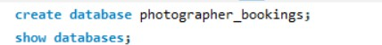

# Tables Created :

## users Table:

Stores user information, including full name, email, password, and phone number. Each user has a unique id as the primary key.

## Columns:

* **id (Primary Key):** Unique identifier for each user.
* **full_name:** User's full name.
* **email:** User's email address.
* **password:** User's password.
* **phone:** User's phone number.

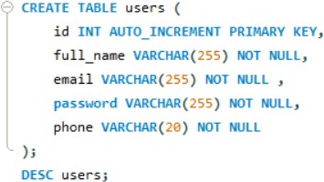

## Photographer Booking:

**event_bookings:**

Stores booking details for event photography sessions, including the client's name, contact information, event type, and event date. Each booking has a unique ID (id), which is the primary key.

## Columns:

### id (Primary Key)

* **full_name:** Client's full name.
* **email:** Client's email address.
* **phone:** Client's phone number.
* **event_type:** Type of event (e.g., wedding, birthday, corporate).
* **event_date:** Date of the event.
* **guests:** Number of guests expected at the event.
* **special_requests:** Any special requests from the client for the event.
* **status:** Current booking status, which can be 'pending', 'confirmed', or 'declined'. The default is 'pending'.

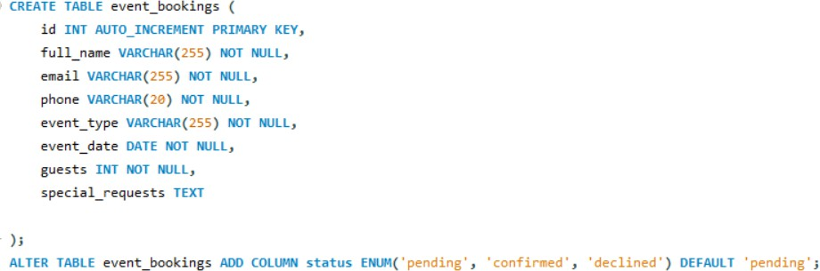

# Milestone 3: SNS Topic Creation

In this milestone, we will create two Amazon SNS topics for booking-related notifications: **photographerBookings** and **clientBookings**. These topics will enable seamless communication and notifications regarding session bookings and updates.

## Activity 3.1: Navigate to the SNS Service

In the AWS Management Console, use the search bar at the top to search for "SNS" or select

**Services** from the top menu.

Under **Application Integration**, click on **Simple Notification Service**.

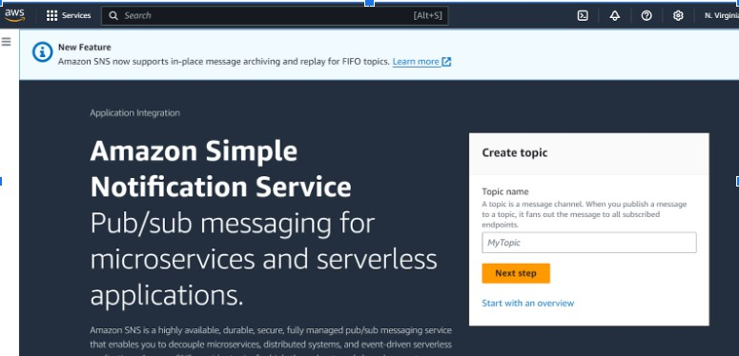

1. Under Application Integration, click on Simple Notification Service.

## Activity 3.2: Create the First Topic (photographerBookings)

1. In the SNS dashboard, click on **Topics** in the left sidebar.
2. Click the **Create topic** button.

Choose **Standard** or **FIFO (First-In-First-Out)** for the topic type. Standard is sufficient for most use cases.

1. Under Details:
2. **Name:** Enter **photographerBookings** as the name for the topic.
3. (Optional) **Display name:** Provide a display name (used for SMS notifications, if applicable).

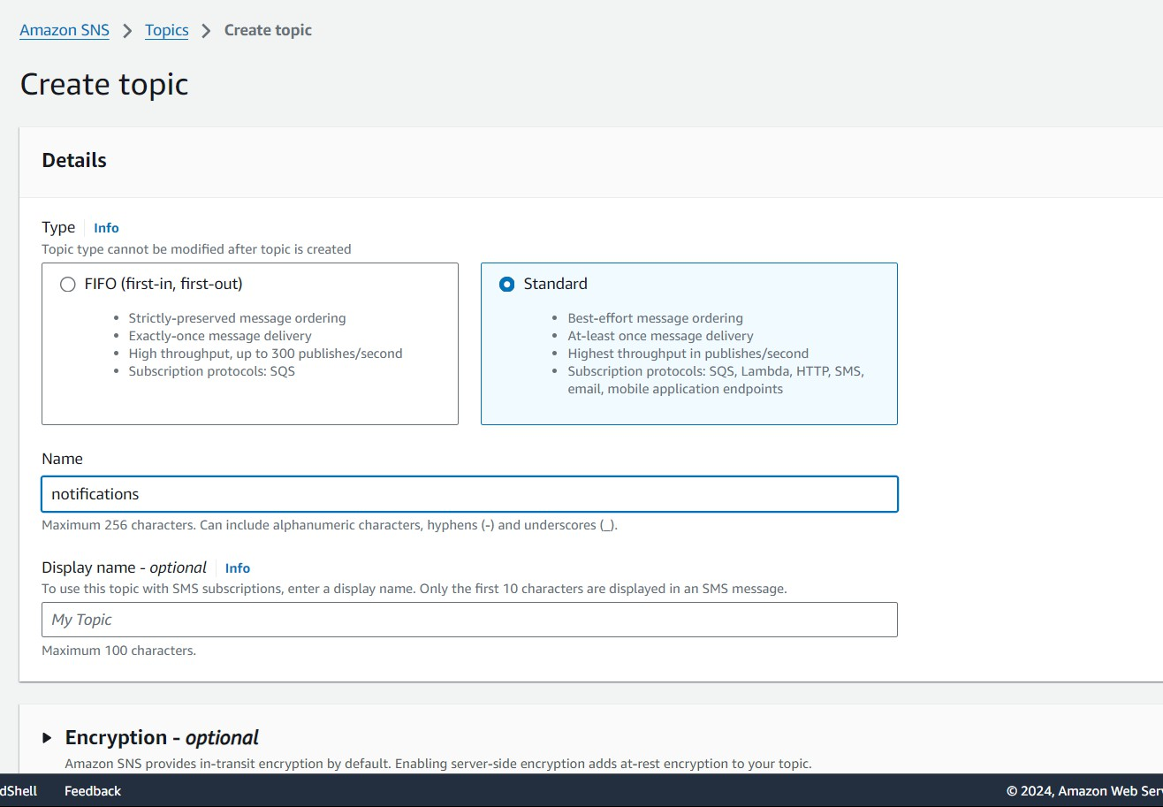

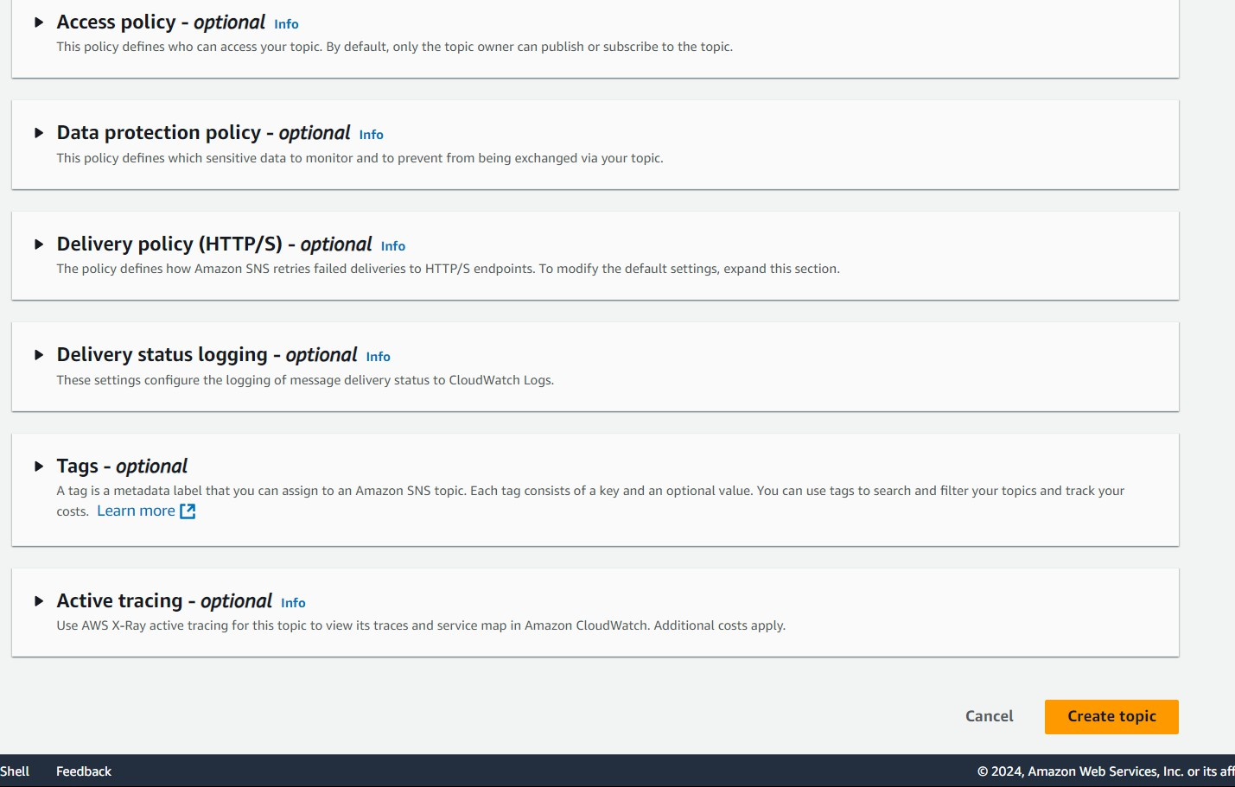

1. Click on the Create topic button.

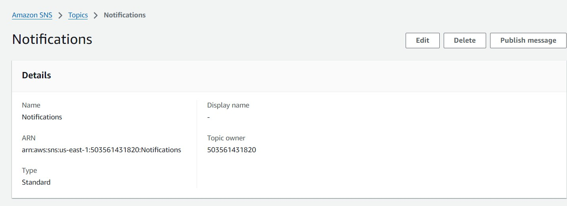

# Milestone 4: Frontend Development and Application Setup

## Activity 4.1: Build the Frontend

* + - Develop HTML, CSS, and Python-based Flask application files for FreshBasket’s frontend interface.

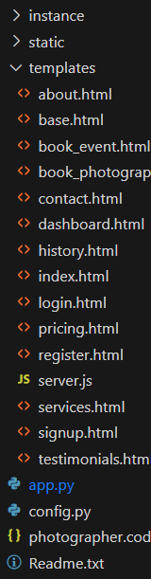

## Activity 4.2: Integrate Application with RDS

* + - Connect app.py (Flask application) to the MySQL RDS database by configuring database connection settings and verifying connectivity.

## Description of the code :

1. **Flask App Initialization**: Initializes a Flask application with a secret key for sessions.

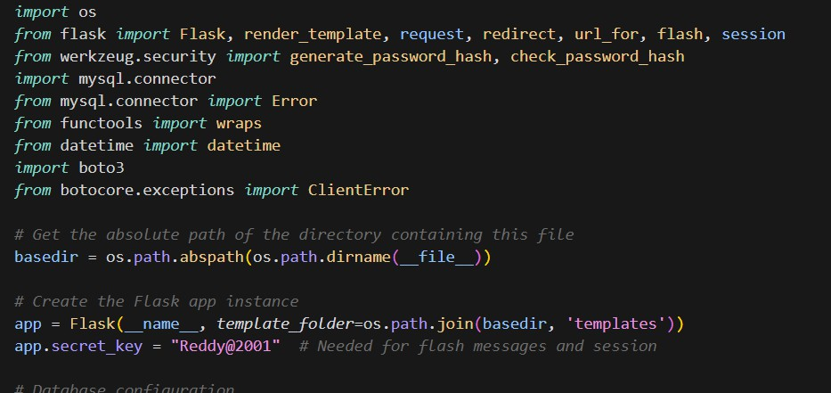

1. **Database Configuration**: Configures MySQL RDS with connection pooling for efficient database access.

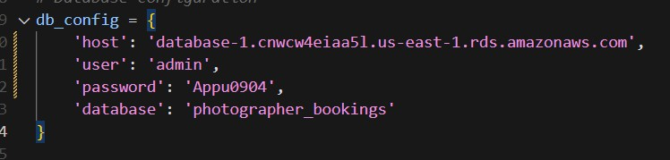

1. **Mysql connector**: Uses MySQL connection pooling to handle multiple database connections.

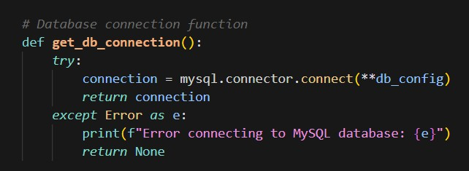

### Initialise SES:

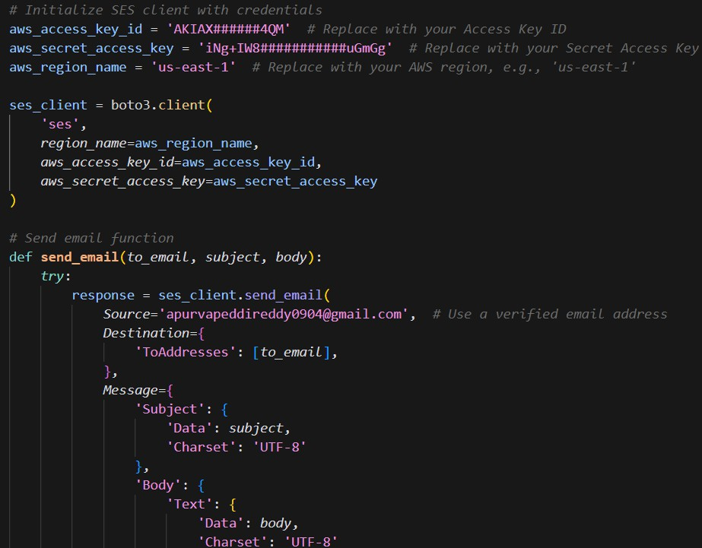

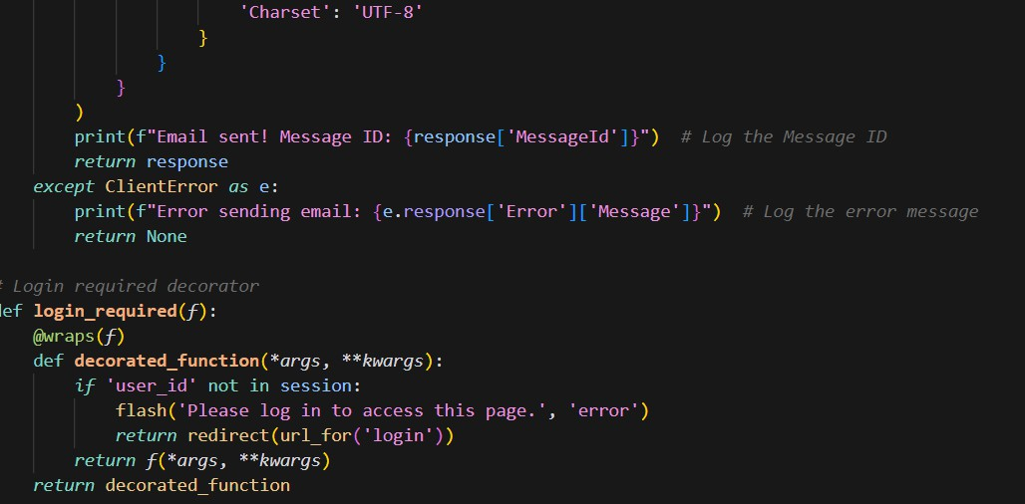

The provided code initializes an Amazon Simple Email Service (SES) client using the Boto3 library, with specific AWS credentials and region settings. It defines a function, send_email, that sends an email to a specified recipient using SES. The function requires the recipient's email address, subject, and body of the email as inputs. If the email is sent successfully, it prints the message ID for logging purposes; otherwise, it captures and prints any errors encountered during the email-sending process. The Source email address must be verified with SES to ensure delivery..

* 1. **Home Route**: Renders the home page template when the root URL is accessed.
  2. **Login(GET/POST)**: Handles user registration, inserts user data into the database.

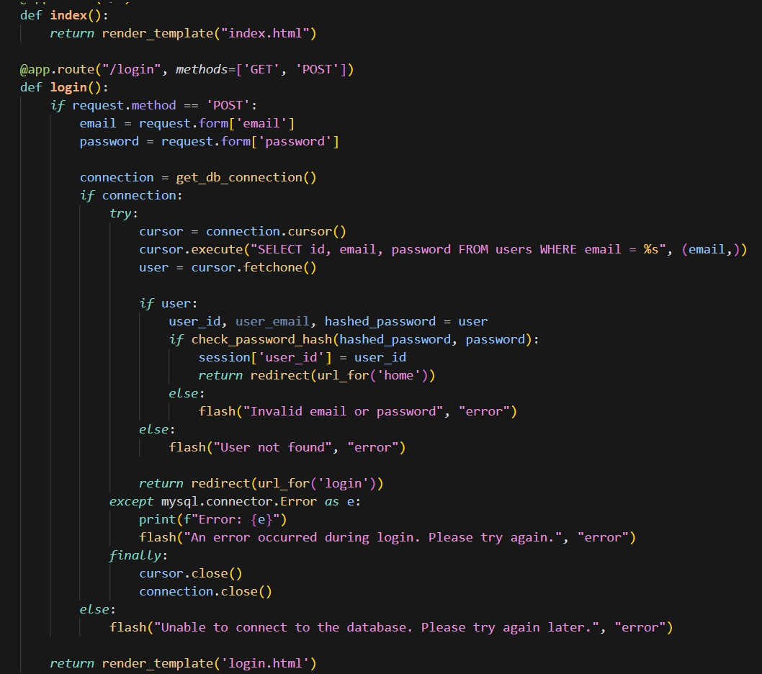

* 1. **Routes for other html pages:**

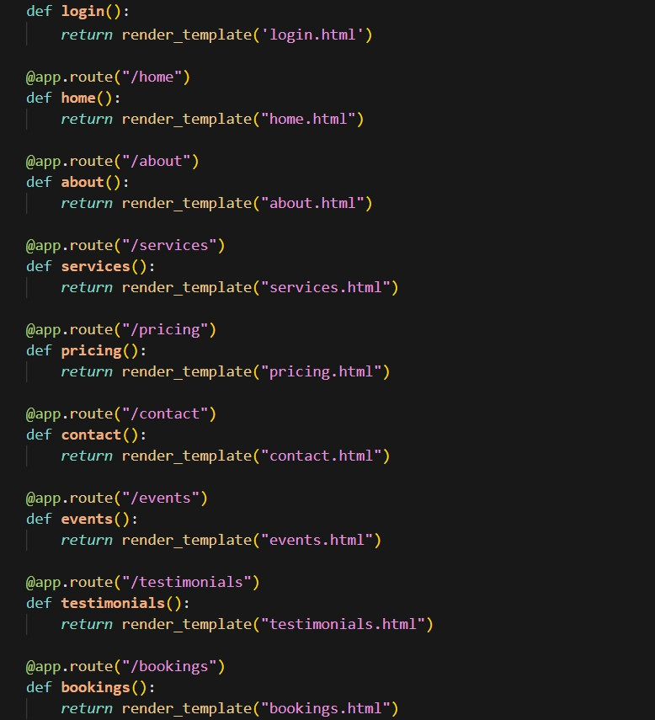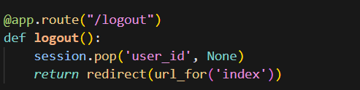

# Signup page:

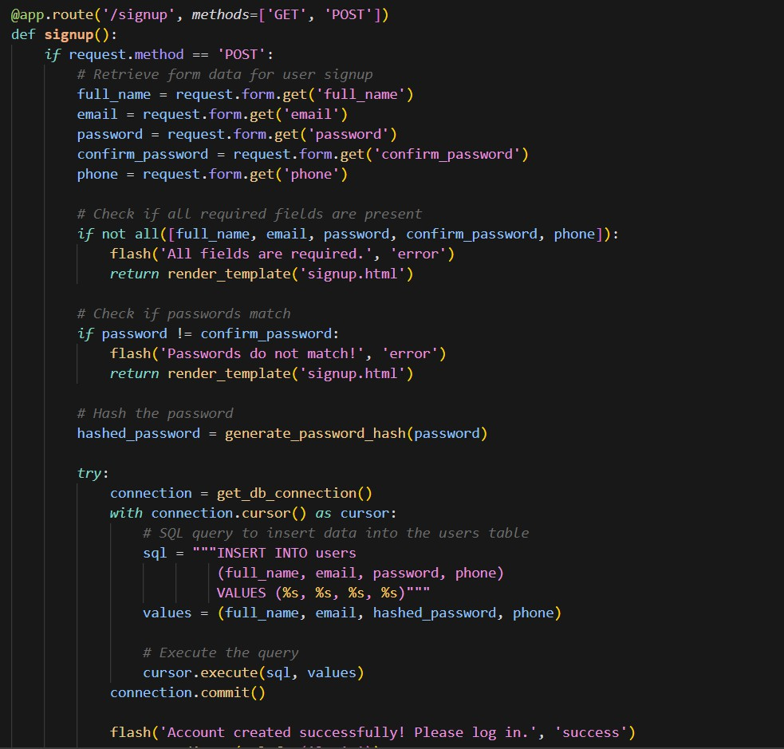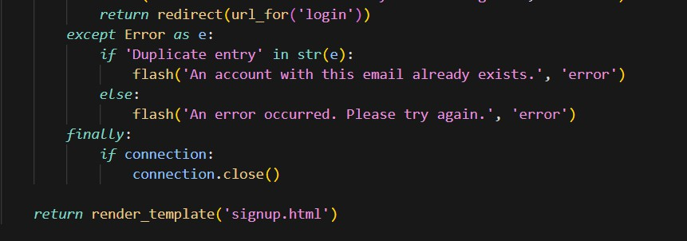

## Booking Route:

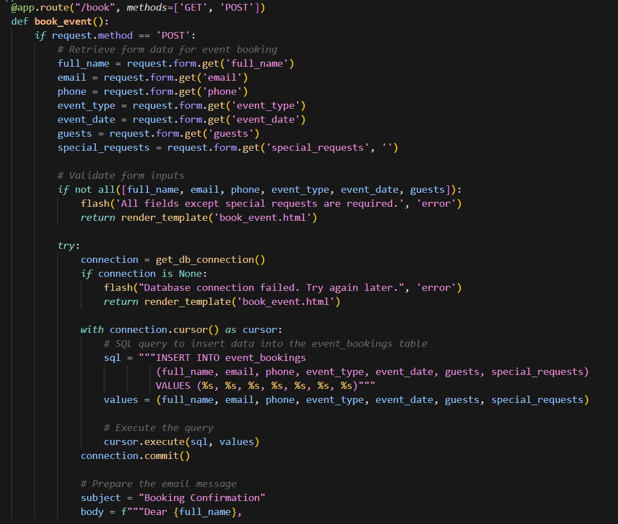

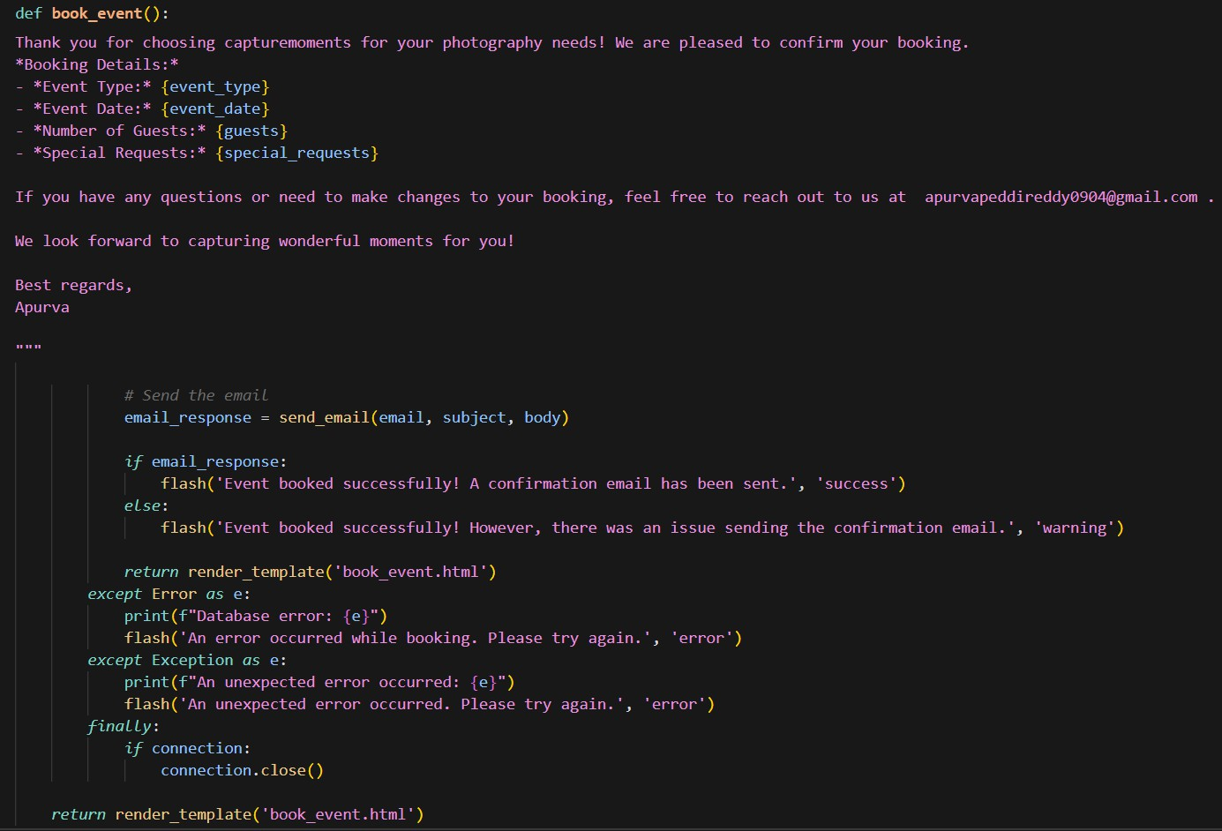

* 1. **Dashboard (GET/POST)**: Allows admin to update order statuses and view detailed orders.

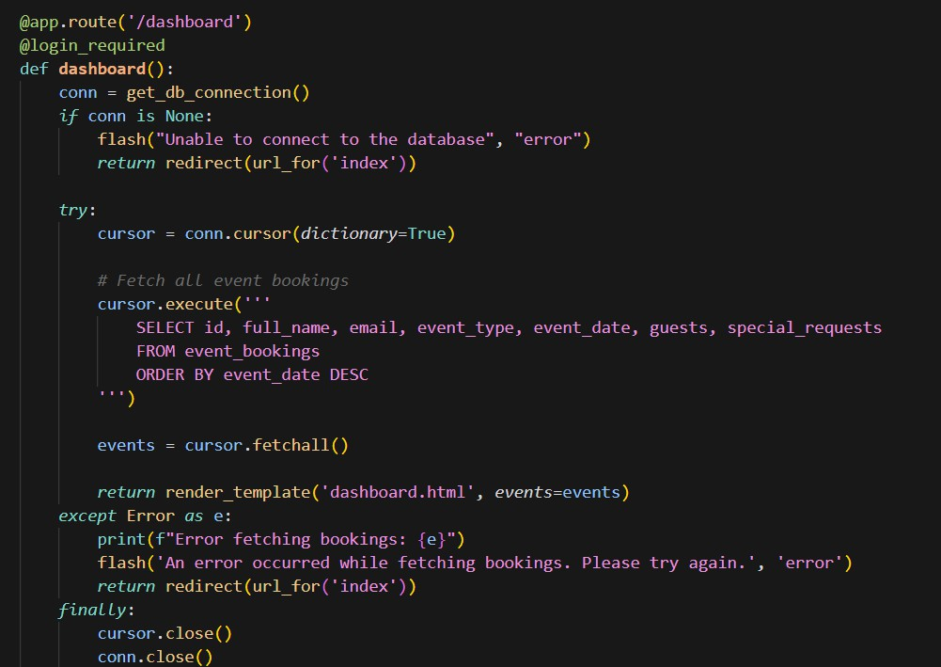

## History Route:

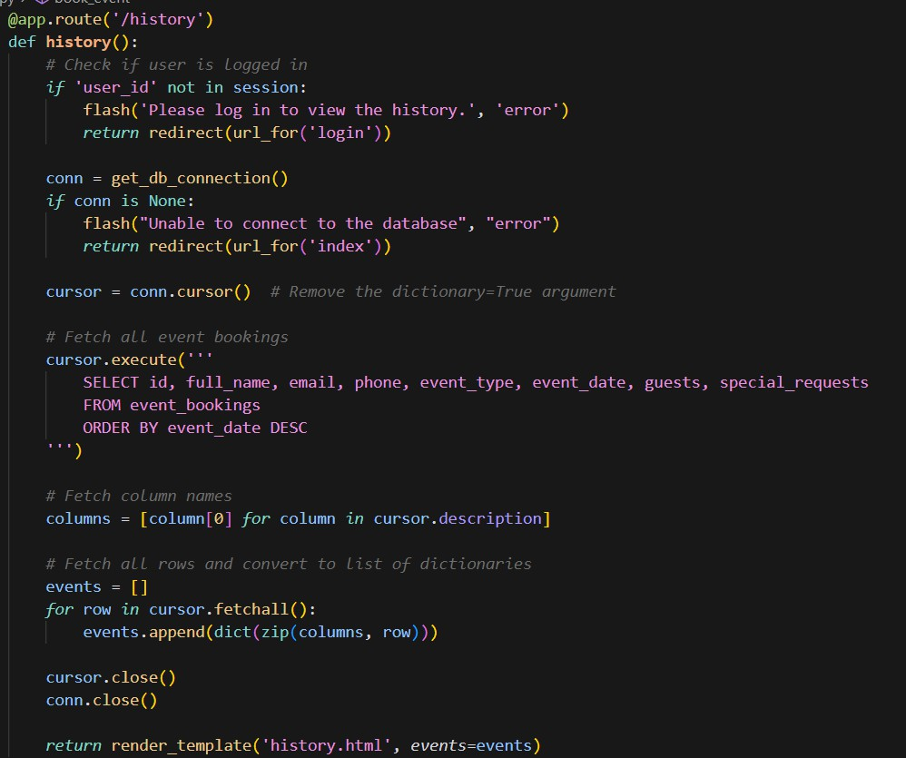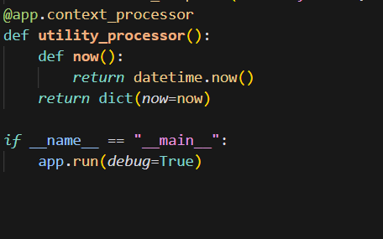

1. **Database Queries**: Uses SQL queries to interact with MySQL RDS for user and order data.
2. **Session Management**: Uses Flask session to store user and cart data for navigation.
3. **Error Handling**: Implements exception handling during order placement to ensure transaction safety.
4. **Booking Status Update**: Admin can change order status, like “confirmed” or “decline.” or”Pending”
5. **Flash Messages**: Provides user feedback through flash messages for login, registration, and updates.
6. **Group Concatenation**: Combines item names in orders for easy display on the dashboards.

# Milestone 5: EC2 Instance Setup

## Activity 5.1: Launch EC2 Instance

* + - Choose a Linux-based EC2 instance from the AWS Console to host the FreshBasket application.

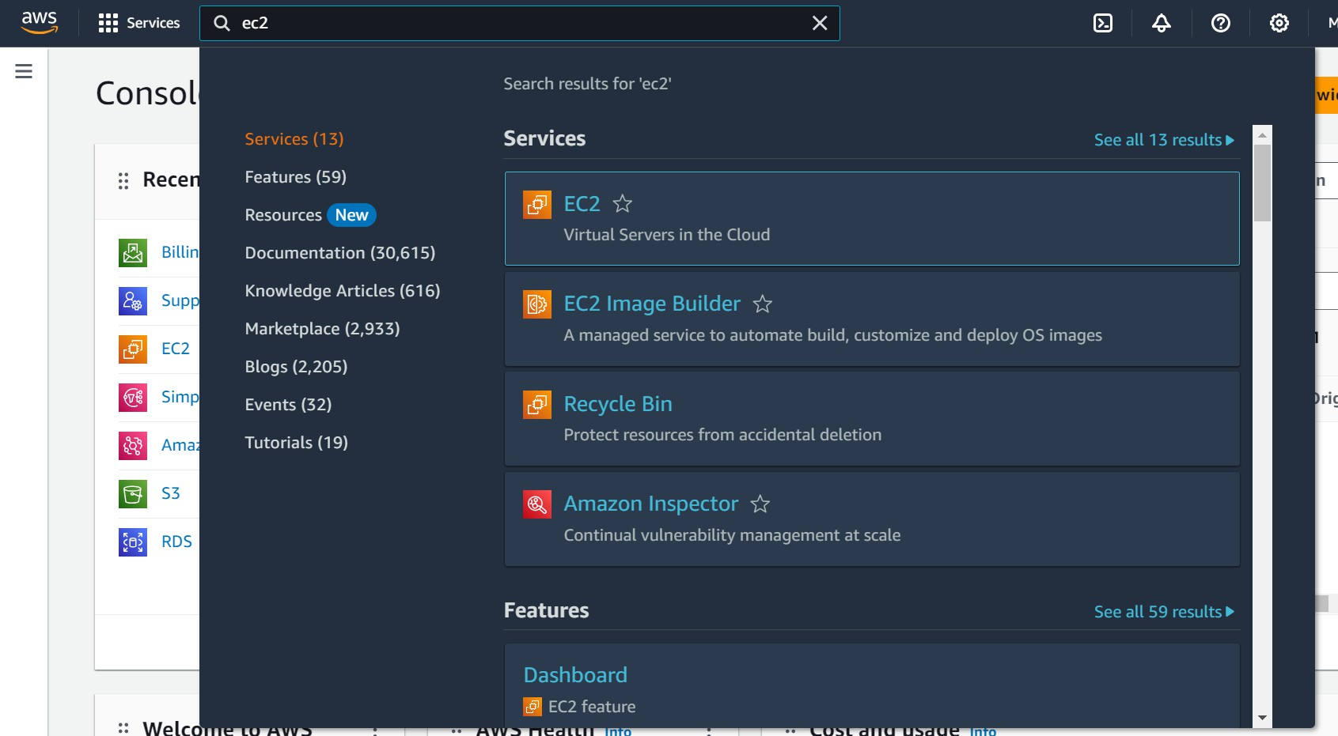

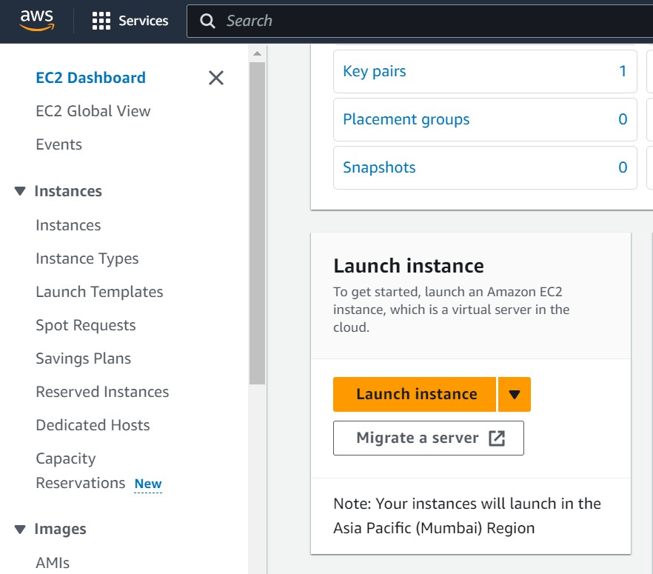

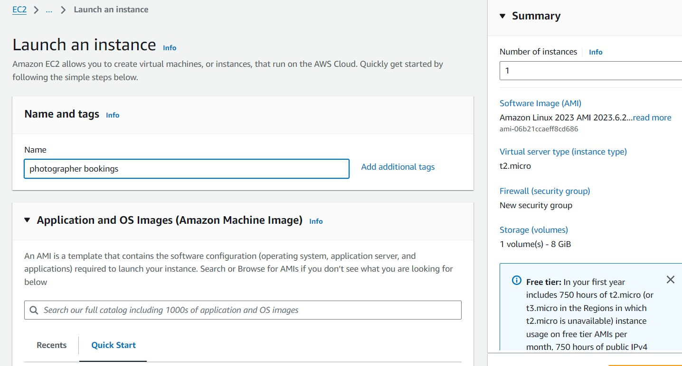

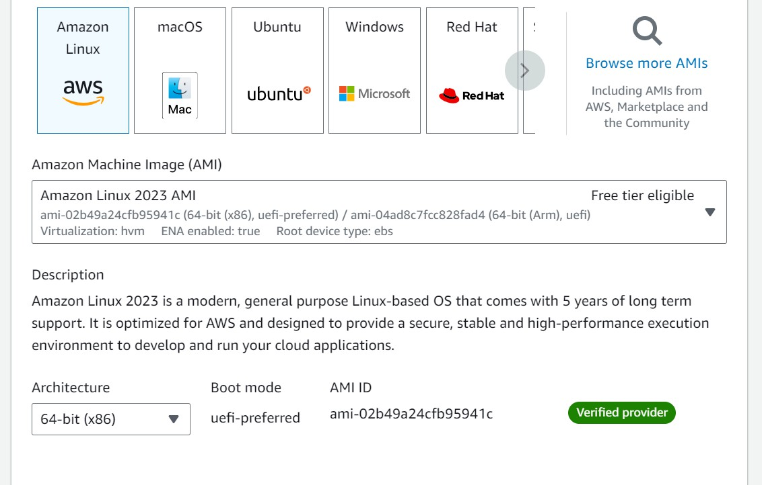

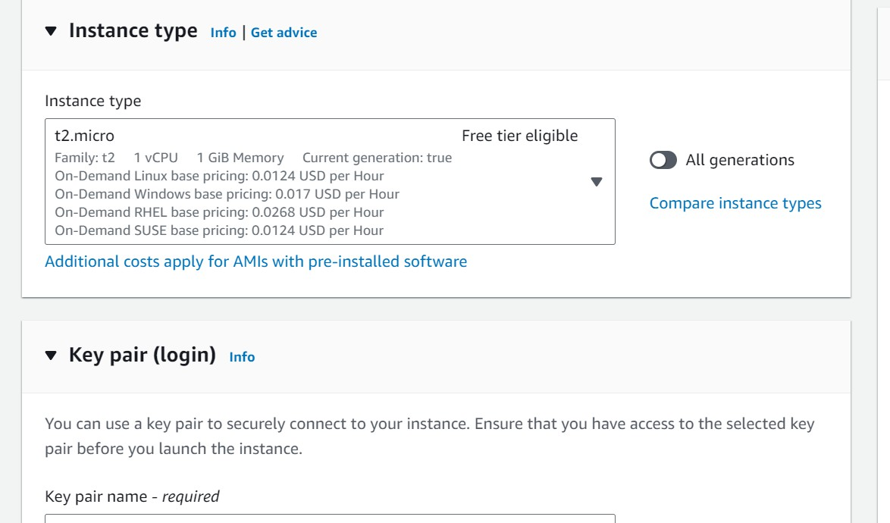

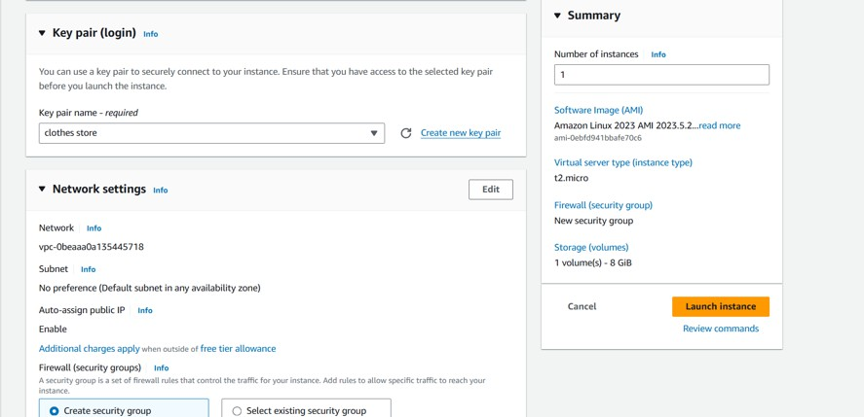

## Activity 4.2: Configure Network Settings

* + - Set up the security group to allow HTTP, HTTPS, and SSH traffic.

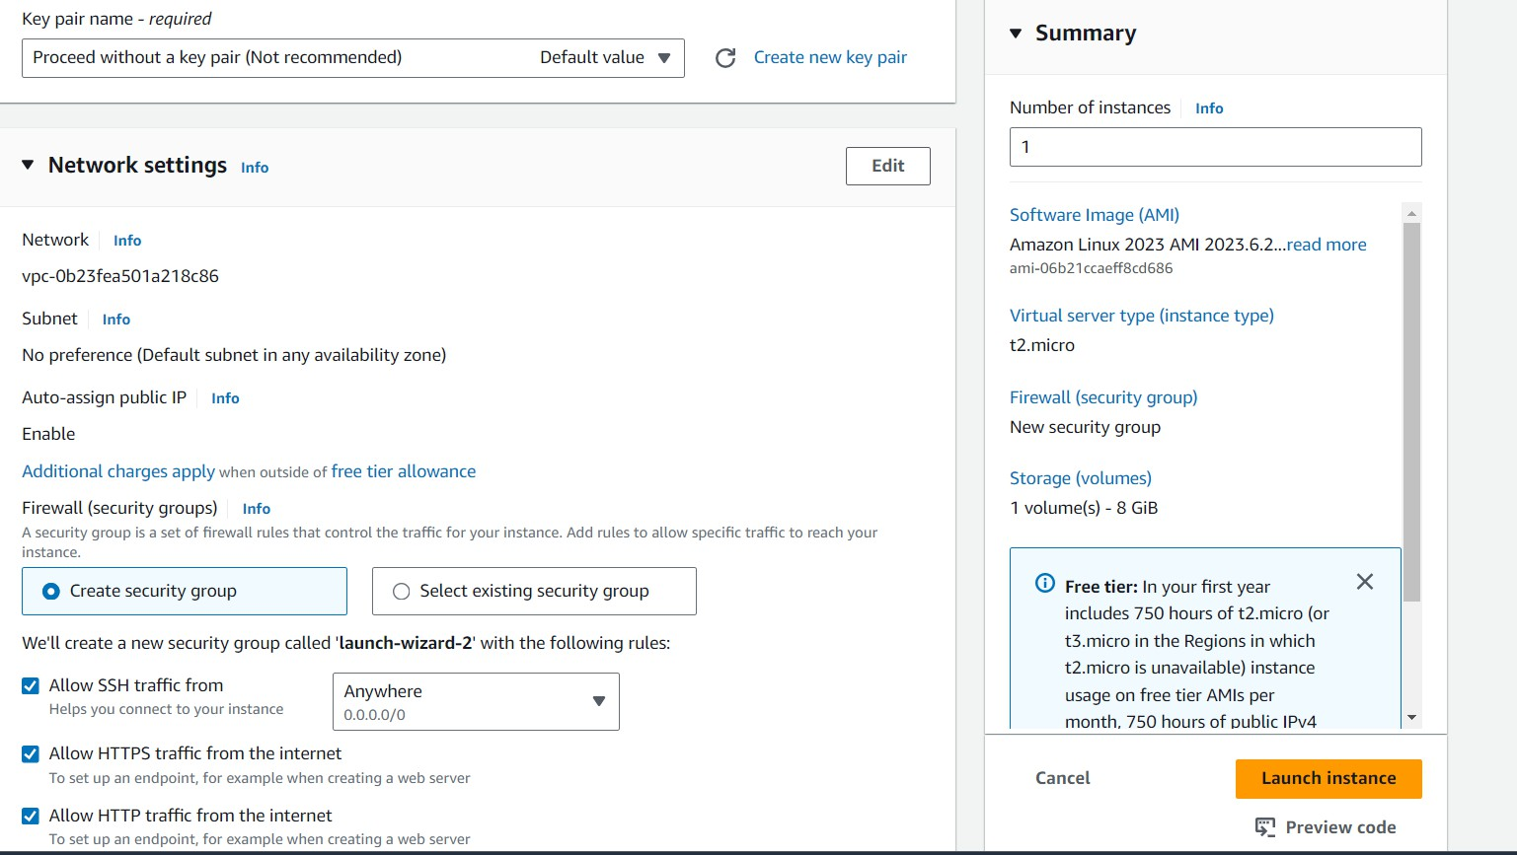

* + - Create and download the key pair for SSH access.

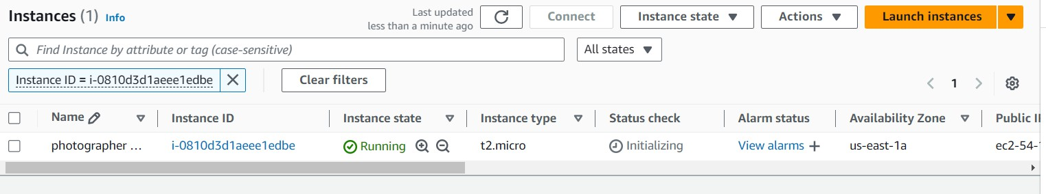

## Setting up Inbound and Outbound rules

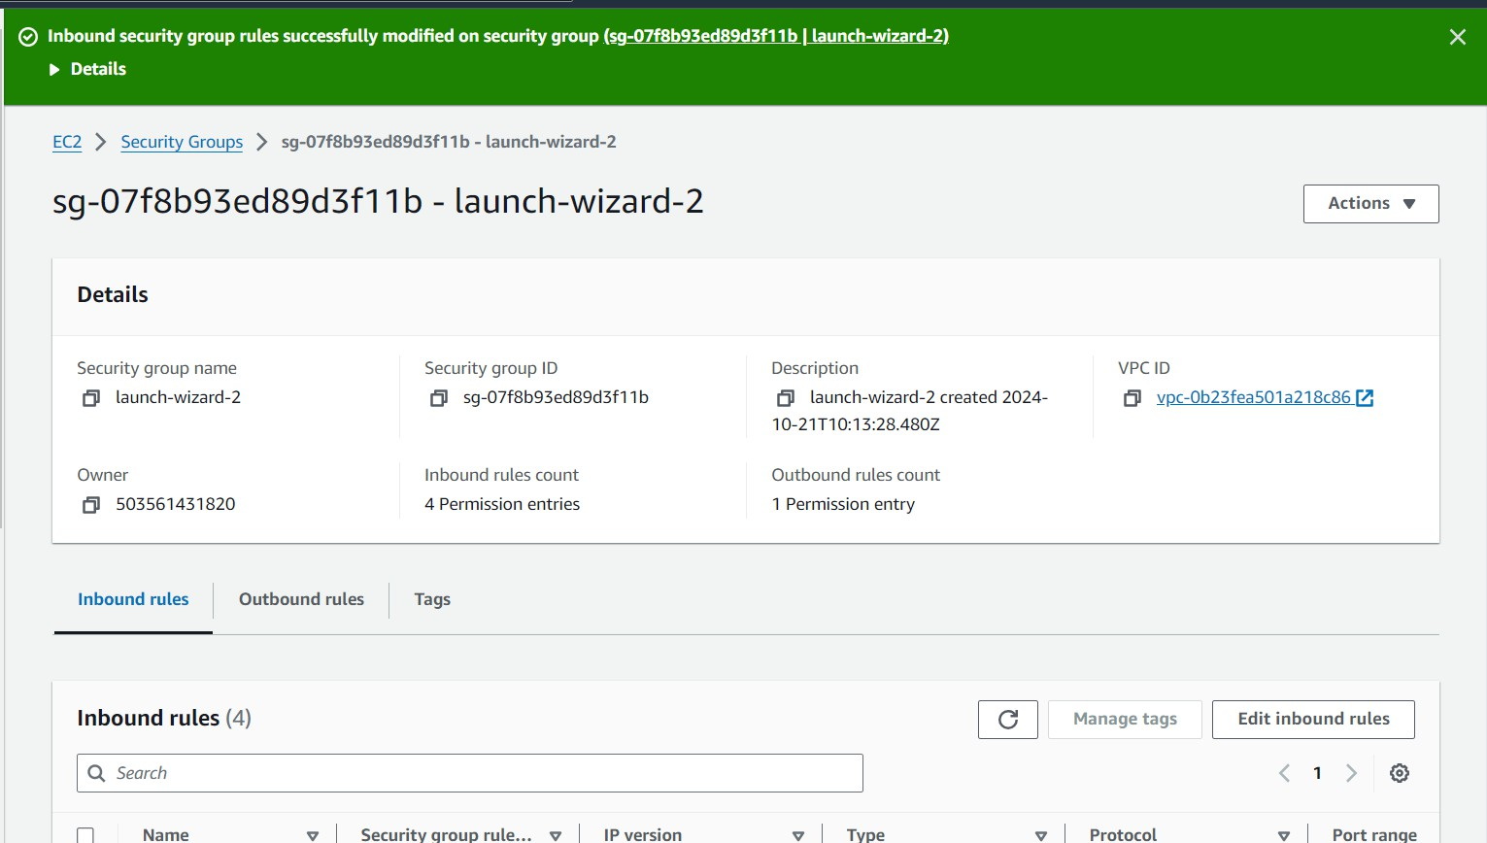

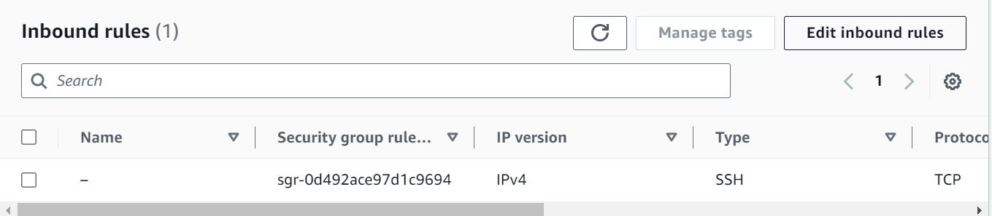

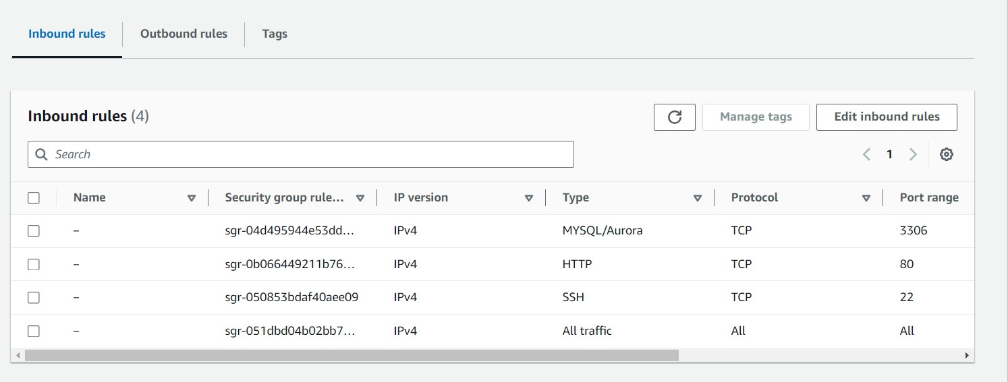

* + Add Type : HTTP > Source : Anywhere
  + Add Type : HTTPS > Source : Anywhere

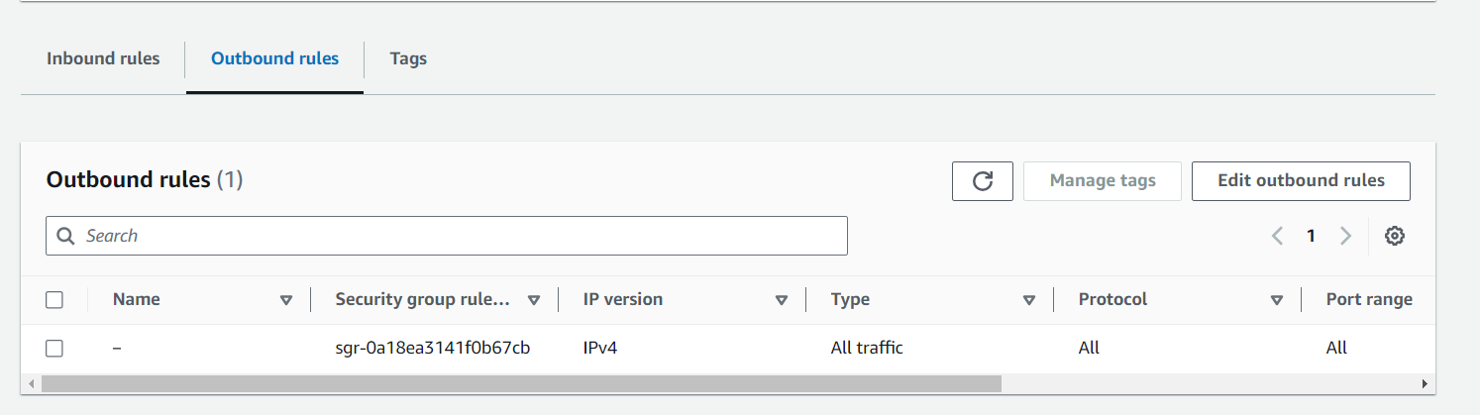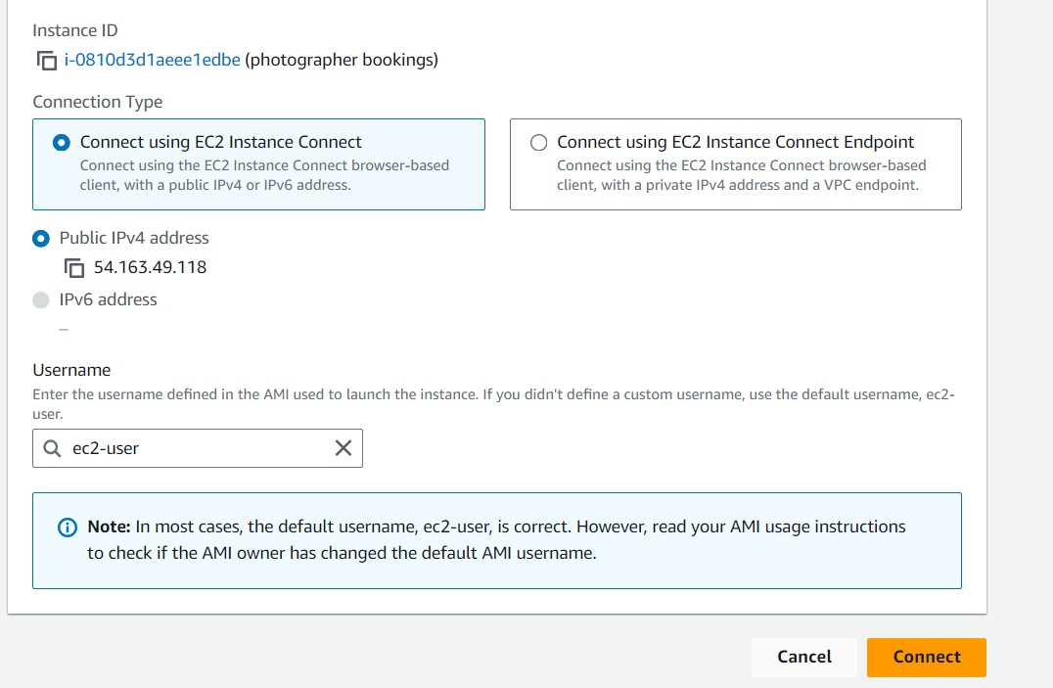

# Milestone 6: Testing and Deployment

## Activity 6.1: Functional Testing

* + - Test the StyleLane application for functionality, including database interactions and frontend features.
    - Run the Flask app **python3 app.py**
    - It will give you the link
    - 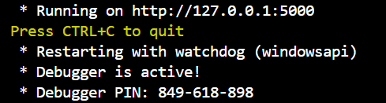

## Activity 6.2: Deployment

* + - Deploy the application in a production environment, ensuring high availability and performance.

Click on the link above and it will take you to the webpage:

**Home:**

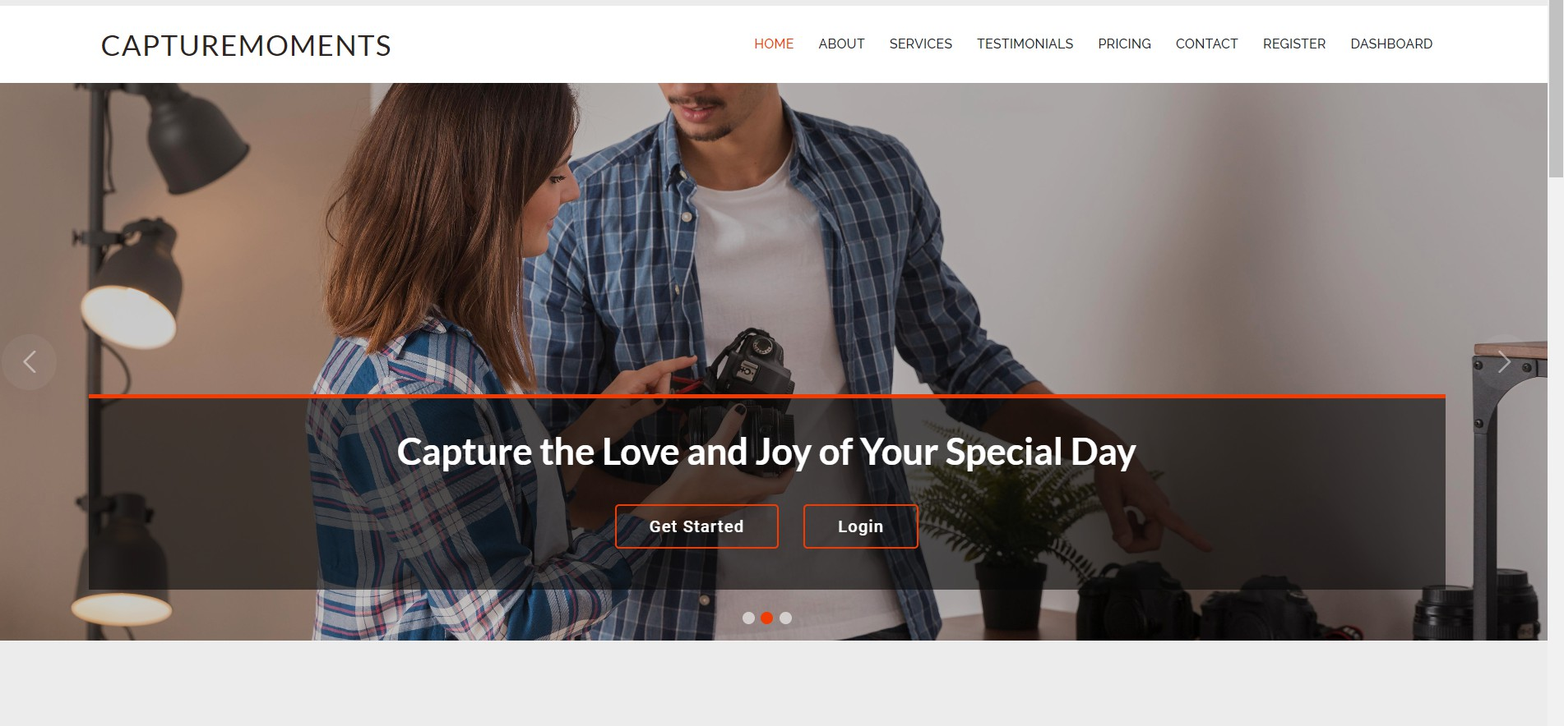

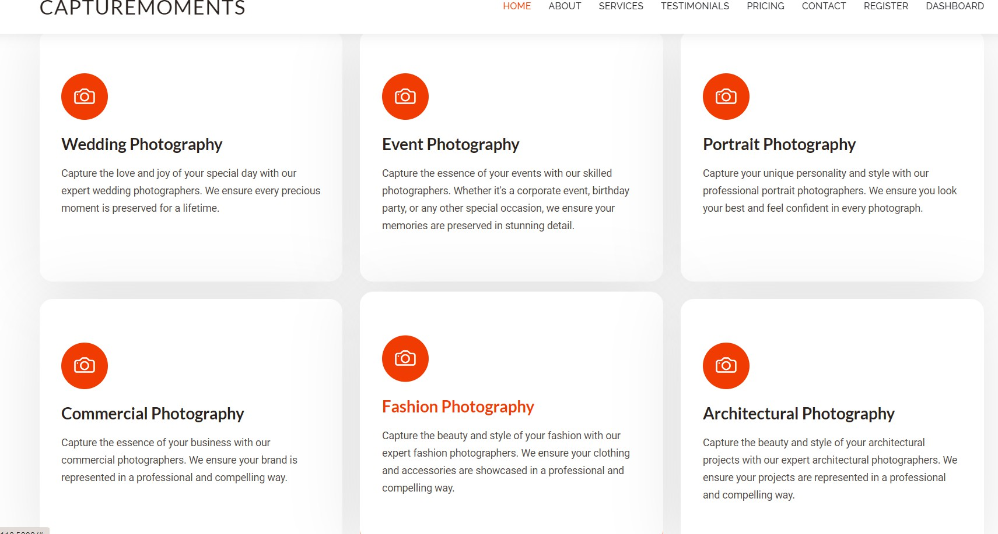

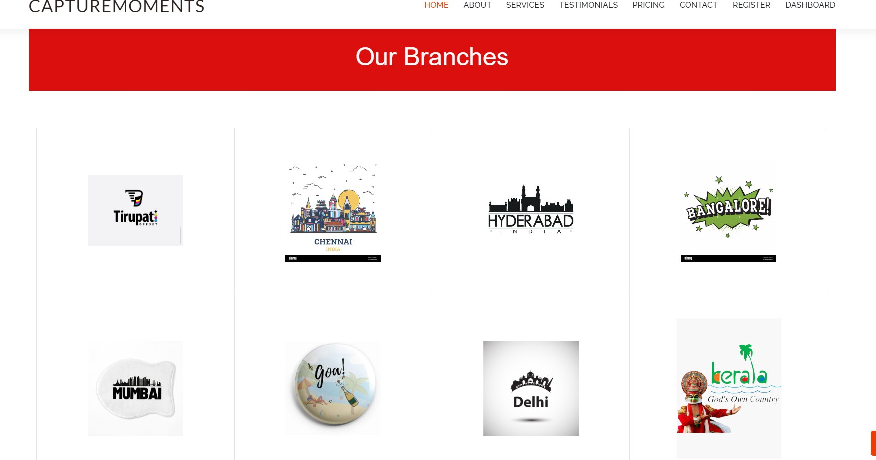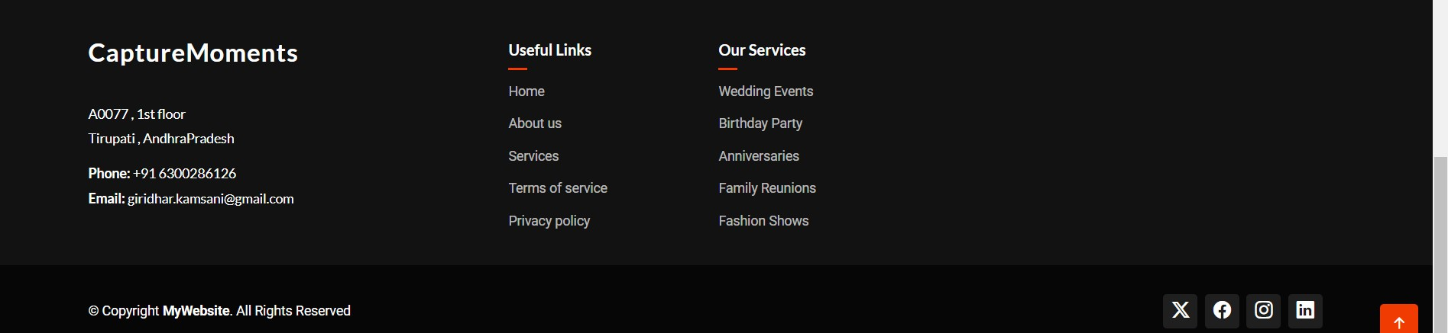

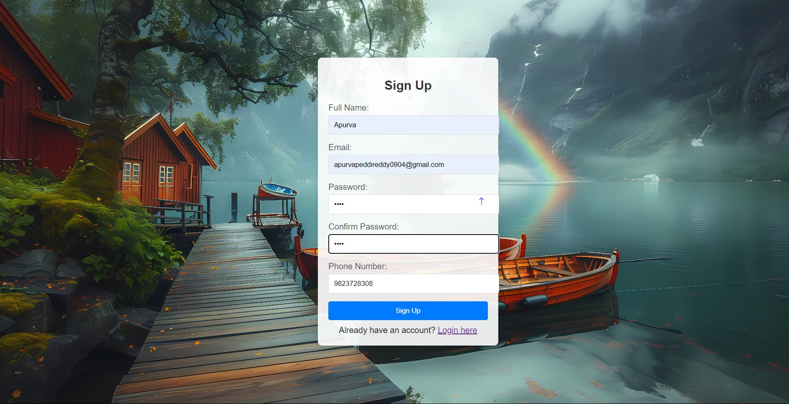**Register:**

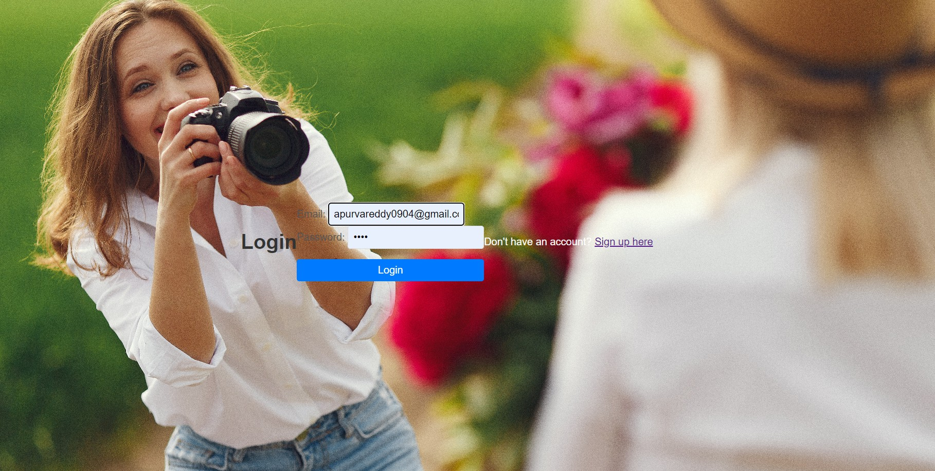**Login:**

**About:**

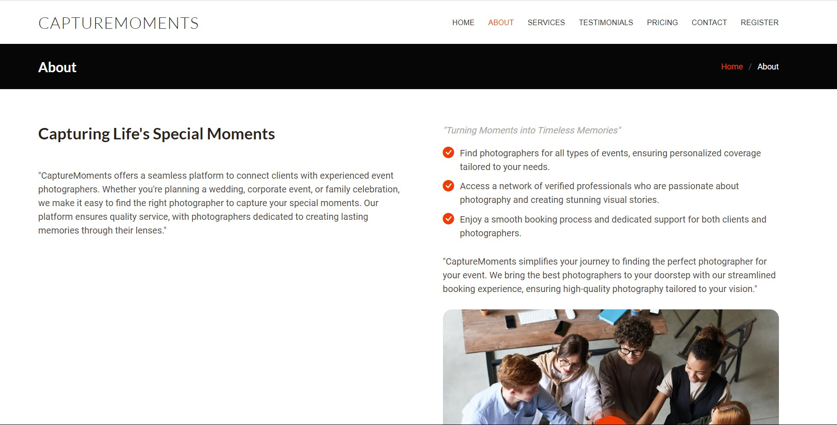

**Contact:**

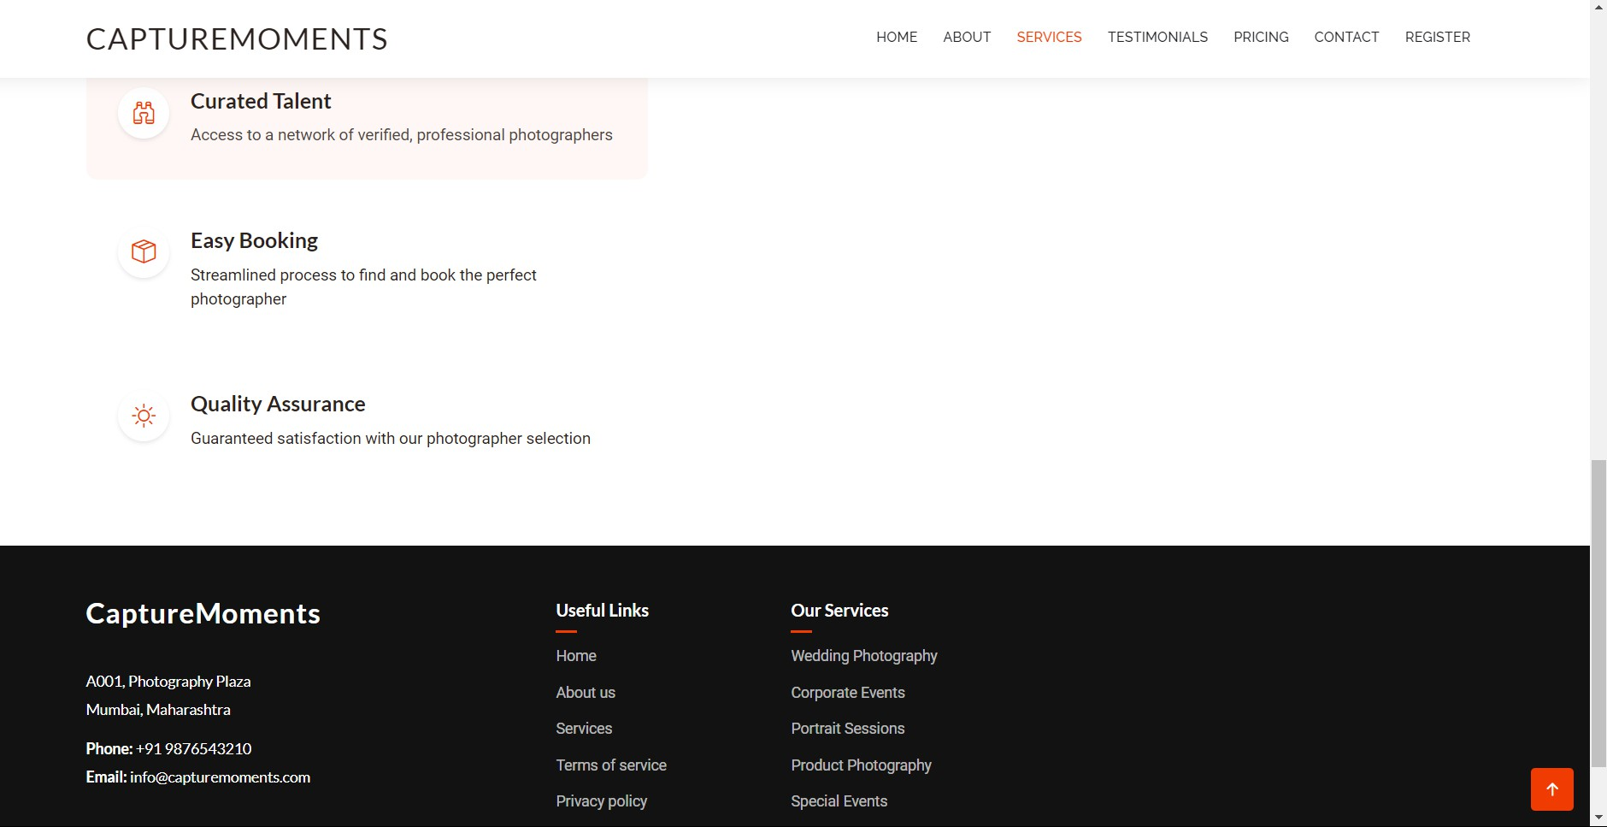

**Testimonials:**

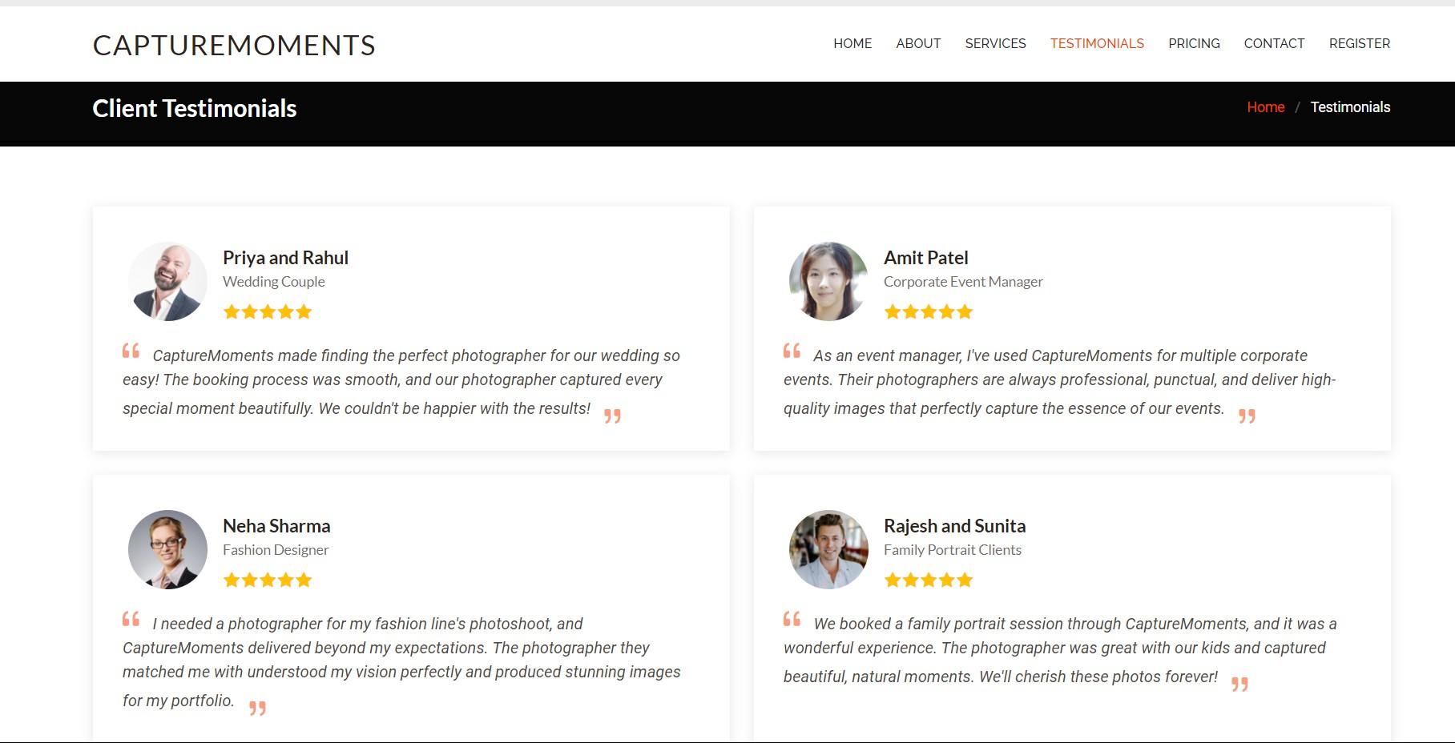

**Photographer Booking:**

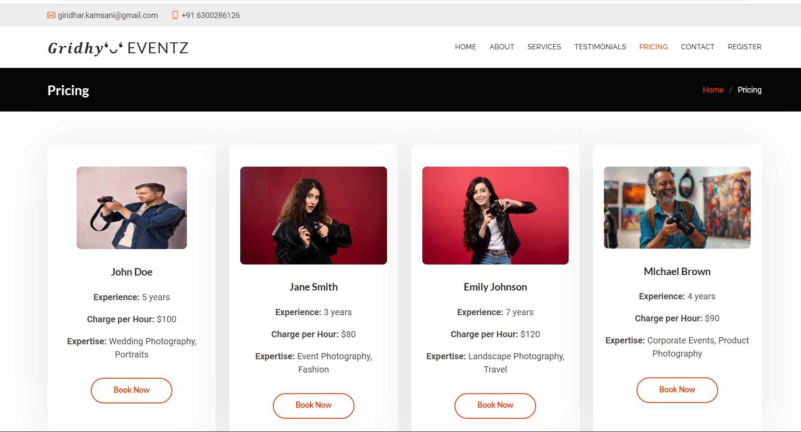

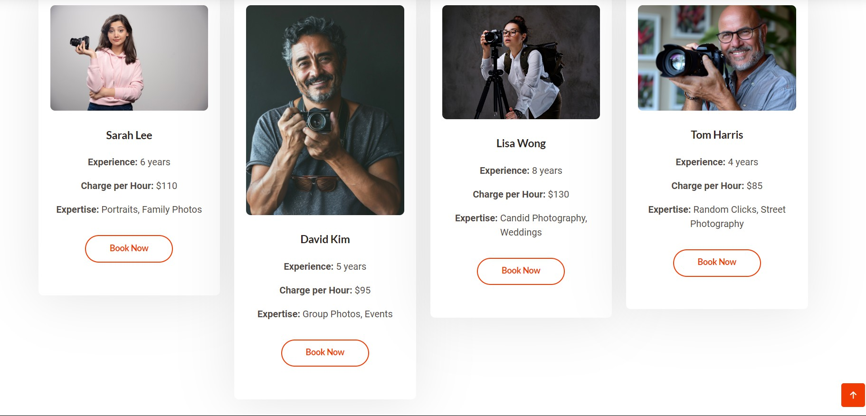

**BOOKING Form:**

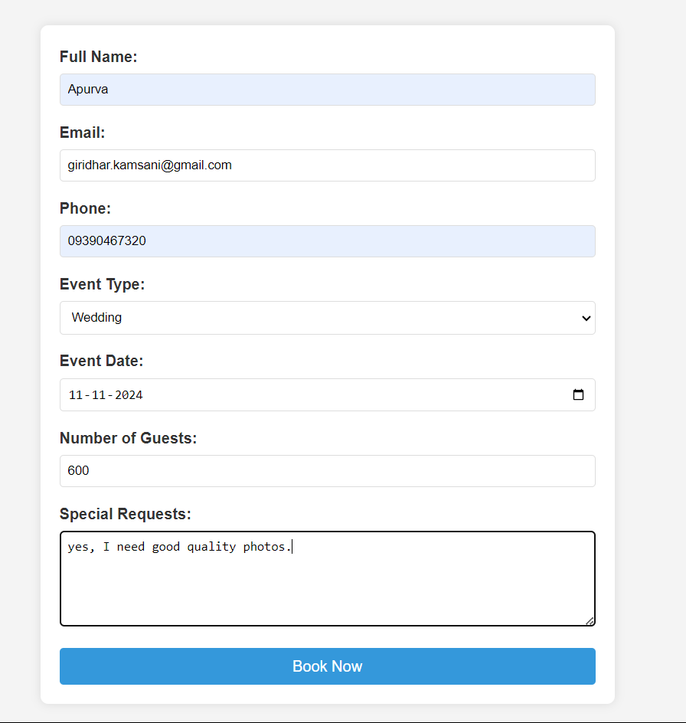

**After booking Successful mail sent to user from photographer:**

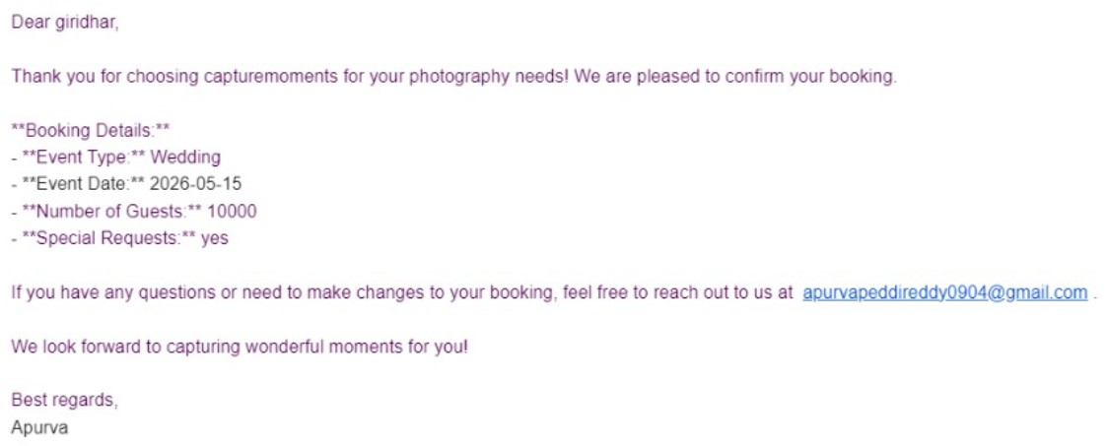

**Admin Dashboard:**

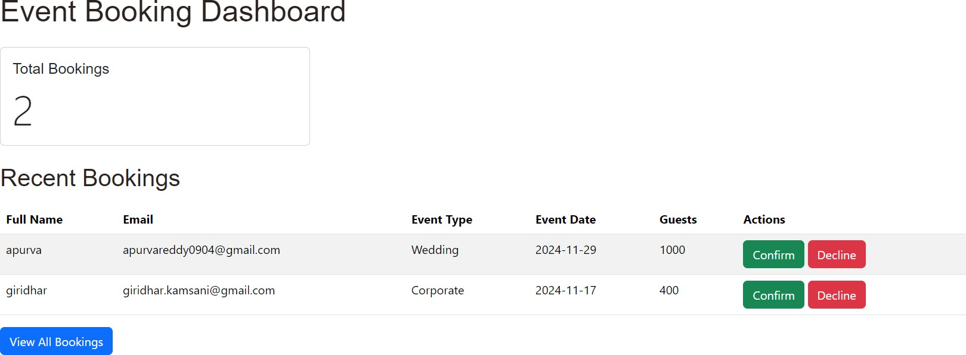

**History:**

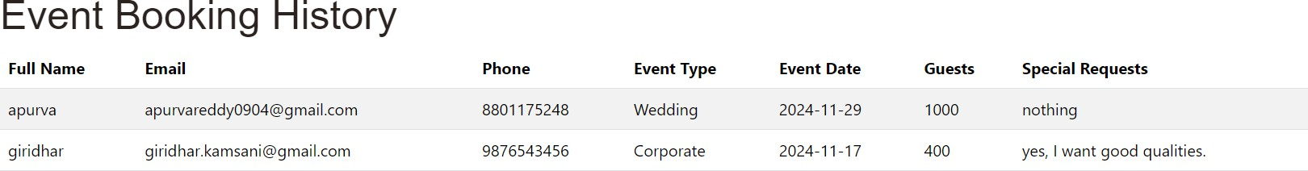

* **Activity 6.3: Check the updations in the mysql database. MySql Database updations :**

1. 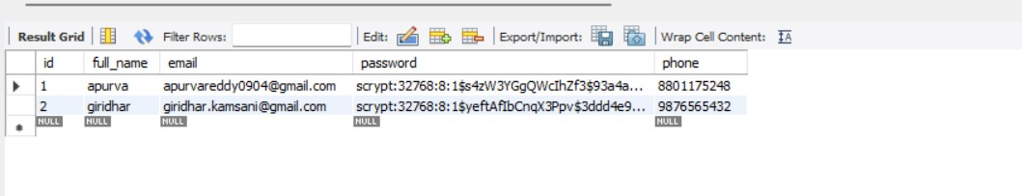**Users table :**
2. **Booking table :**

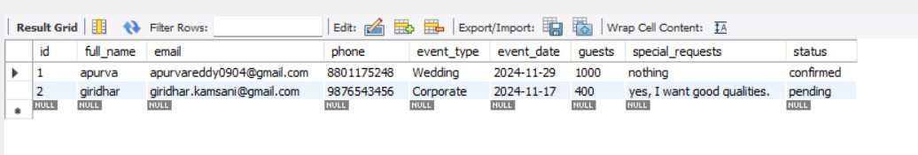

**Conclusion:**

The "Photographer Booking Platform on AWS" streamlines the scheduling process for event and portrait photography by leveraging AWS services like EC2, RDS, and SNS. It ensures real-time notifications for both photographers and clients, enhancing communication and preventing missed appointments. With scalable infrastructure, the platform can handle increased traffic during peak booking seasons, while AWS RDS securely manages booking data. Overall, this cloud-based solution improves the user experience, making photography bookings more efficient and organized for all parties involved.